2D Barcode Reader User Guide

Table of Contents
1 Getting Started 3
1.1 About This Guide 3
1.2 Barcode Scanning 3
1.3 Factory Defaults 3
1.4 Firmware Version Number 3
2 Communication Interfaces 4
2.1 RS-232 Interface 4
2.2 Baud Rate 5
2.3 Data Bit & Parity Check & Stop Bit 6
2.4 XON/XOFF 6
2.5 USB HID-KB 7
2.6 USB Country Keyboard Types 7
2.7 Convert Case 11
2.8 Transmission speed 11
2.9 Function Code Transmit 12
2.10 USB COM Port Emulation 12
3 General Configuration 13
3.1 Trigger Mode 13
3.2 Auto Sense 14
3.3 Presentation Mode 14
3.4 Illumination Lights 14
3.5 Illumination-Manual Trigger 15
3.6 Illumination-Presentation 15
3.7 Idle Illumination-Presentation 15
3.8 LED Idle State-Presentation 16
3.9 Continue-Scan Presentation Mode 16
3.10 Power-Up Beeper 16
3.11 Good Read Beeper 17
3.12 Good Read Beeper Volume 17
3.13 Good Read Beeper Duration 17
3.14 Good Read Beeper Tone 18
3.15 Vibrate-Good Read 18
3.9 Good-read Delay 19
3.10 Reread Delay 19
3.11 Accepting RS-232 Commands 20
4 Data Formatting 21
4.1 General Configuration 21
4.2 Add Prefix 22
4.3 Add Suffix 23
4.4 Clear All Prefix and Suffix 23
5 Symbologies 24
5.1 General Setting 24
5.2 1D Symbologies 24
5.2.1 Code 128 24
5.2.2 EAN-8 25
5.2.3 EAN-13 28
5.2.4 UPC-E 30
5.2.5 UPC-A 33
5.2.6 Interleaved 2 of 5 36
5.2.7 Matrix 2 of 5 37
5.2.8 Industrial 2 of 5 38
5.2.9 Code 39 39
5.2.10 Coda Bar 42
5.2.11 Code 93 44
5.2.12 GS1-128 45
5.2.13 MSI 46
5.2.14 Code 11 47
5.3 2D Symbologies 49
5.3.1 PDF 417 49
5.3.2 QR Code 51
5.3.3 Data Matrix 52
5.3.4 Maxi code 54
5.3.5 Aztec 55
5.3.6 Hanxin 56
5.4 Postal Symbologies 57
5.4.1 China Postal Code 57
5.4.2 Telepen 57
6 Appendix 58
6.1 Appendix 1: AIM ID Table 58
6.2 Appendix 2: ASCII Table 60
6.3 Appendix 3: Digit Barcodes 64

Getting Started

About This Guide
This guide provides programming instructions for the SuperLead 2D Barcoder Reader. Users can configure the SuperLead 2D Barcoder Reader by scanning the programming barcodes included in this manual.

Barcode Scanning
Powered by area-imaging technology and SuperLead 2D Barcoder Reader patented “Hercules” technology, the SuperLead 2D Barcoder Reader features fast scanning and decoding accuracy. Barcodes rotated at any angle can still be read with ease. When scanning a barcode, simply center the aiming beam or pattern projected by the SuperLead 2D Barcoder Reader over the barcode.

Factory Defaults
Scanning the following barcode can restore the engine to the factory defaults.
Note: Use this feature with discretion.

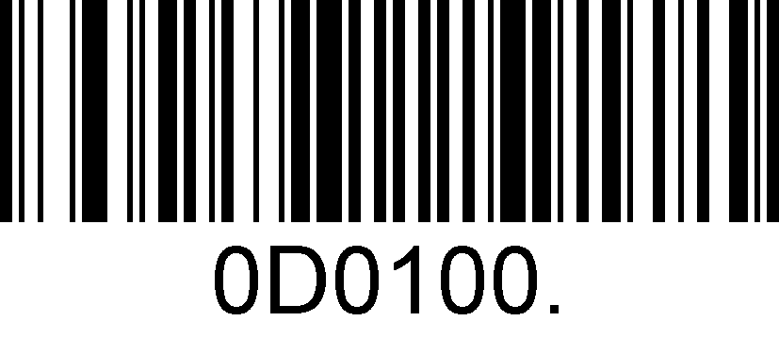
Restore All Factory Defaults

Firmware Version Number
Scanning the barcode below can display the firmware version number.

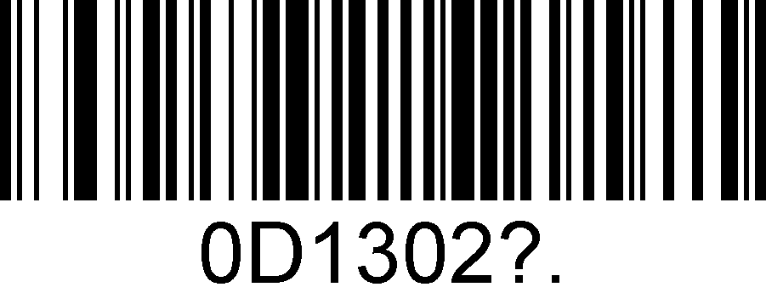
Display The Firmware Version Number

Communication Interfaces
The SuperLead 2D Barcoder Reader provides a RS-232 interface and a USB interface to communicate with the host device. The host device can receive scanned data and send commands to control the engine or to access/alter the configuration information of the engine via the RS-232 or USB interface.

RS-232 Interface
Serial communication interface is usually used when connecting the engine to a host device (like PC, POS). However, to ensure smooth communication and accuracy of data, you need to set communication parameters (including baud rate, parity check, data bit and stop bit) to match the host device.
The serial communication interface provided by the engine is based on RS-level signals.
Default serial communication parameters are listed below. Make sure all parameters match the host requirements.

Parameter | Factory Default
Serial Communication | Standard RS-232
Baud Rate | 115200
Parity Check | None
Data Bits | 8
Stop Bits | 1
Hardware Flow Control | None

Note: SuperLead handheld scanners support Auto-Cable function which can be switched 232 interface automatically when connecting with 232cable.

Baud Rate
Baud rate is the number of bits of data transmitted per second. Set the baud rate to match the Host requirements.

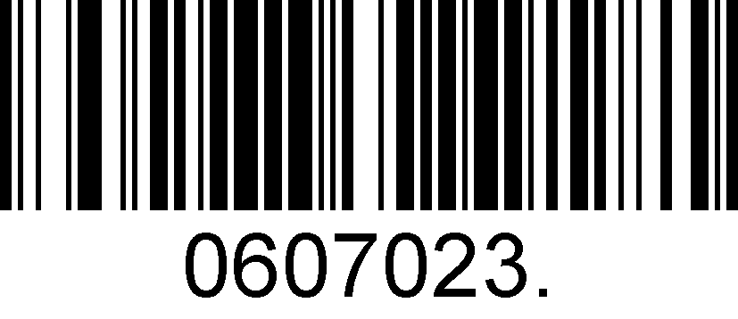
2400
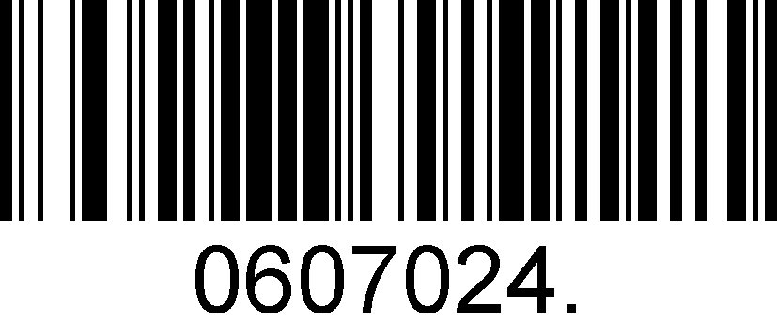
4800
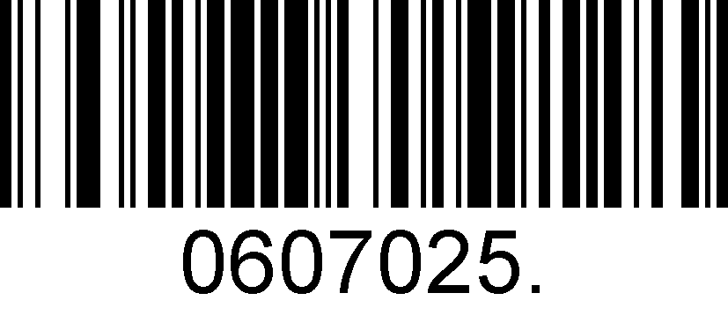
9600
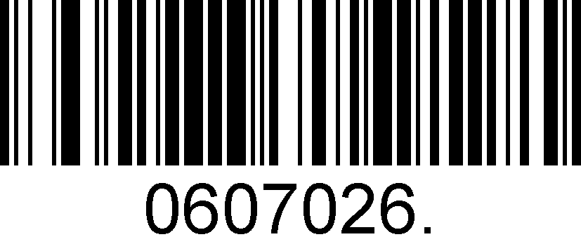
19200
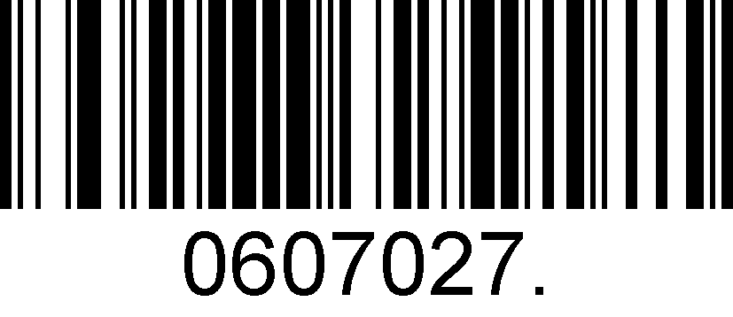
38400
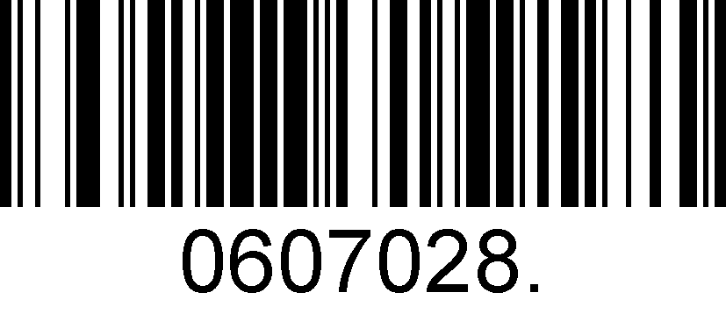
57600
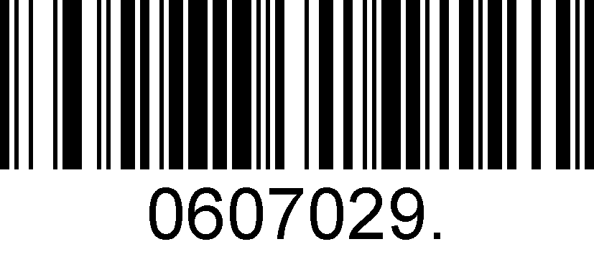
*115200

Data Bit & Parity Check & Stop Bit
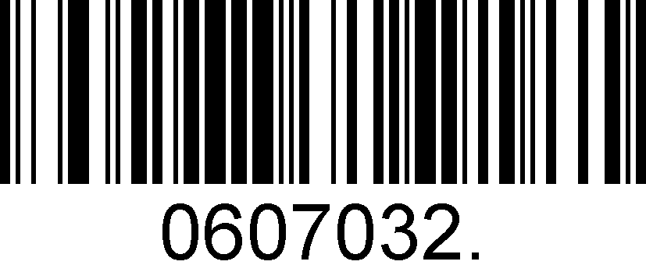
*None Parity /8 Data Bits/1 Stop Bit
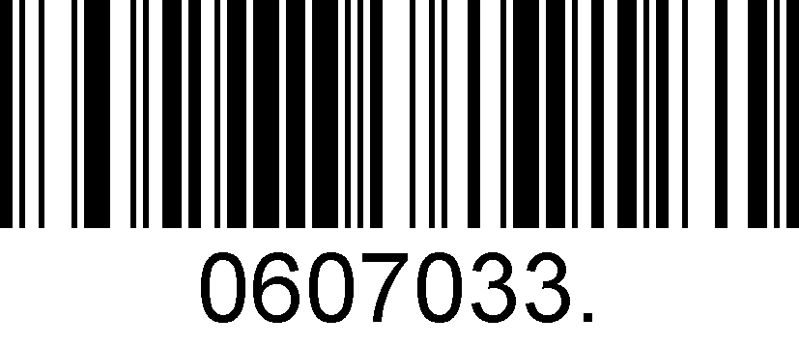
Even Parity /7 Data Bits/1 Stop Bit
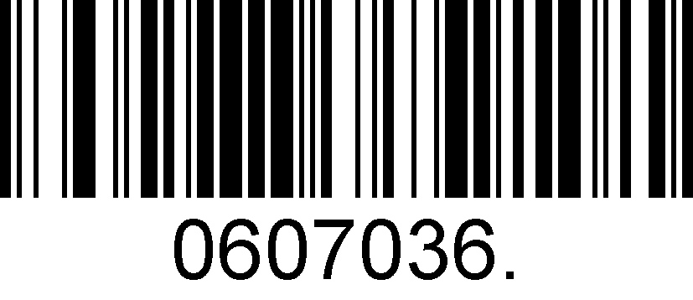
Odd Parity /7 Data Bits/1 Stop Bit

XON/XOFF
The scanner stops sending data when the host sends the XOFF character (hex 13) to it.
To resume transmission, the host sends the XON character (hex 11)

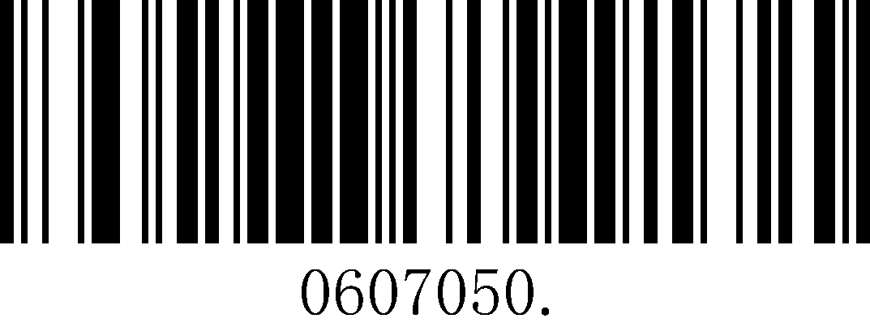
*XON/XOFF Disable
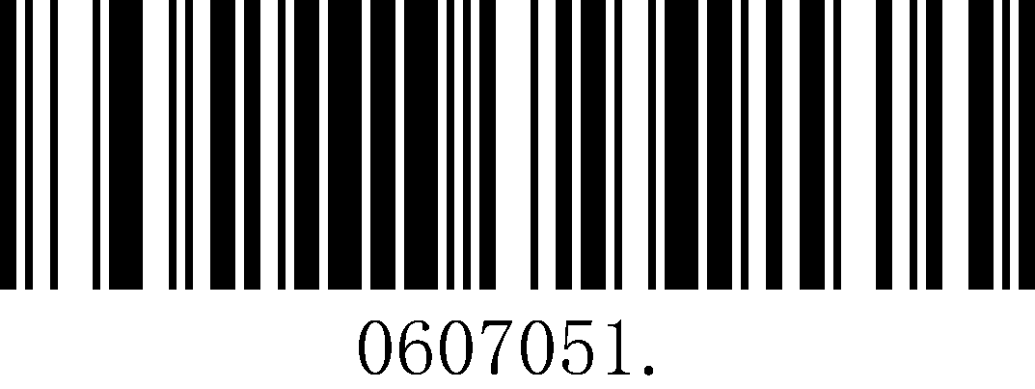
XON/XOFF Enable

USB HID-KB
When you connect the engine to the Host via a USB connection, you can enable the USB HID-KB feature by scanning the barcode below. Then engine’s transmission will be simulated as USB keyboard input. The Host receives keystrokes on the virtual keyboard. It works on a Plug and Play basis and no driver is required.

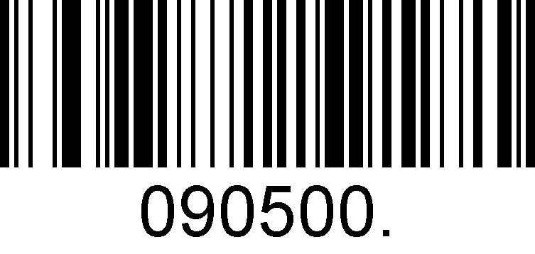
USB HID-KB

USB Country Keyboard Types
Keyboard layouts vary from country to country. The default setting is 1-U.S. keyboard.

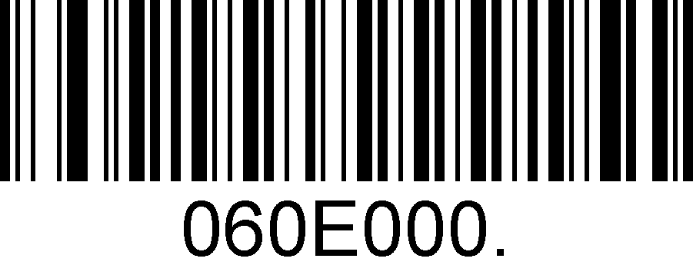
*1 – U.S.
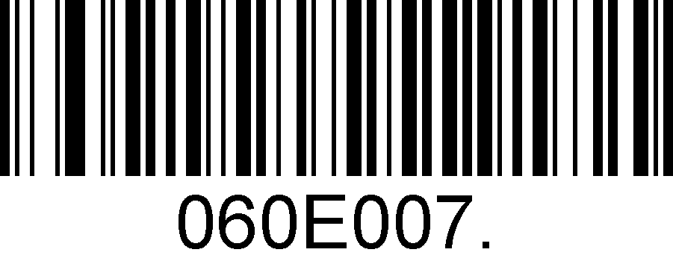
2 – UK
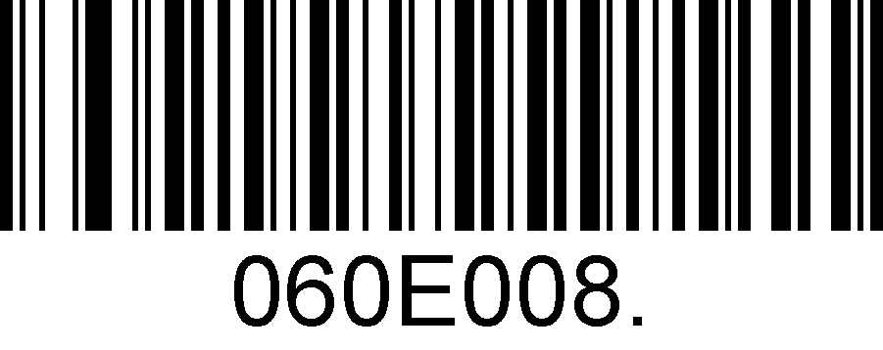
3 – Denmark
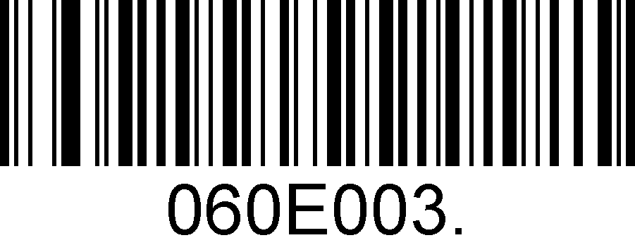
4 – France
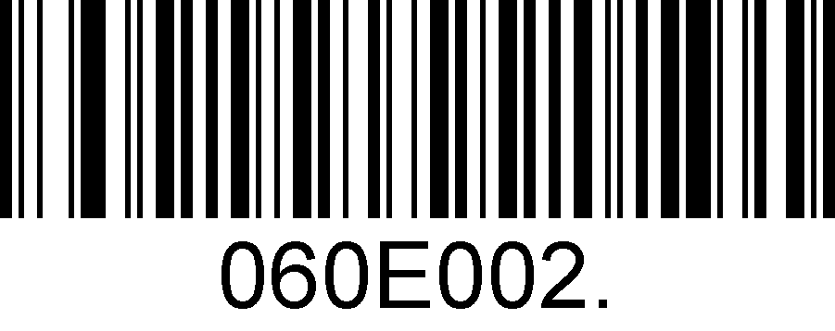
5 – Finland
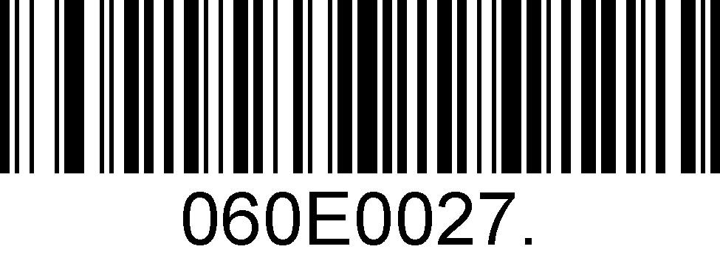
6 – Turkey_F
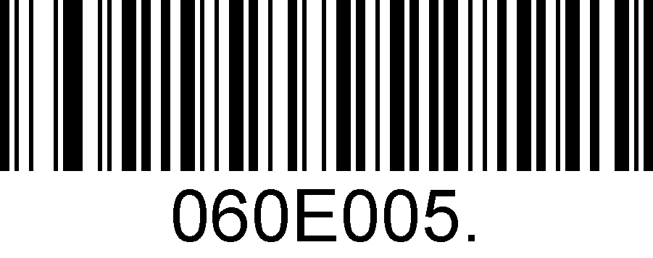
7 – Italy
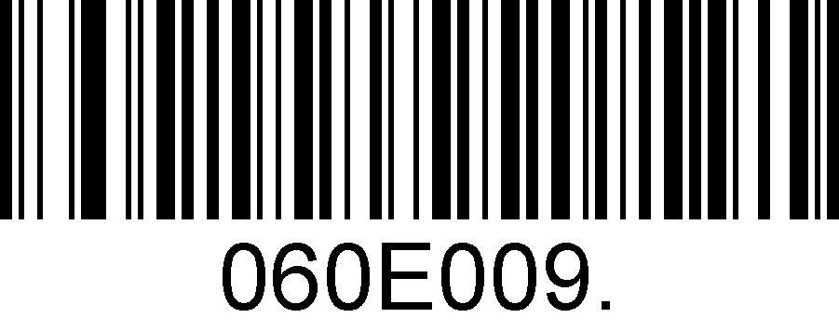
8 – Norway
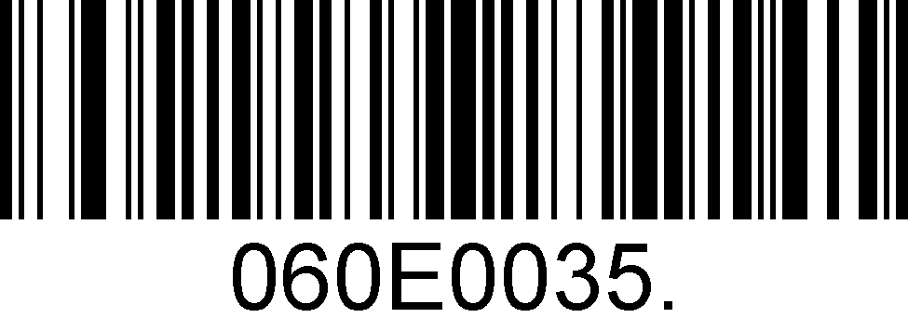
9 – Albania
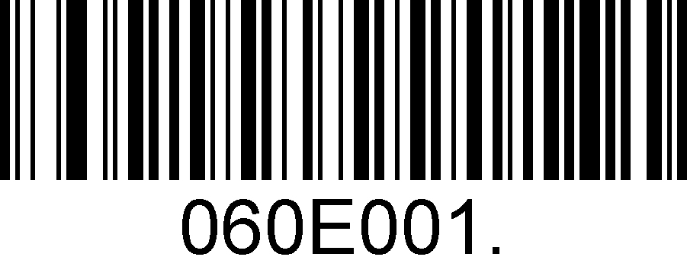
10 – Belgium
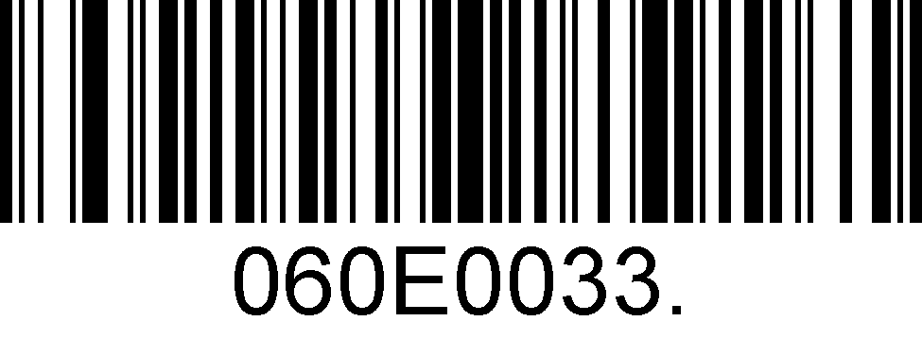
11 – Bosnia
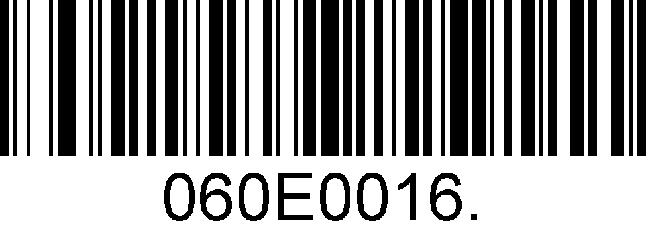
12 – Brazil
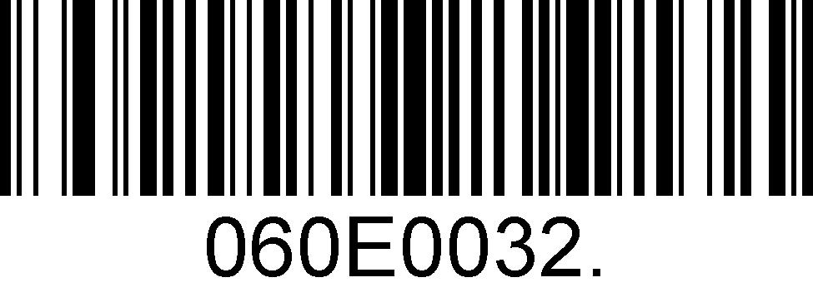
13 – Croatia
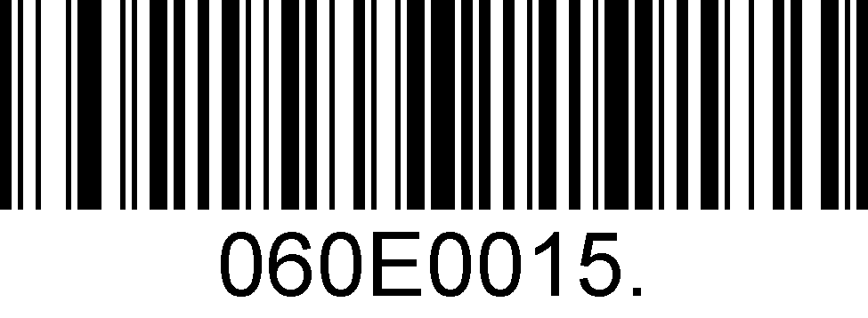
14 – Czech
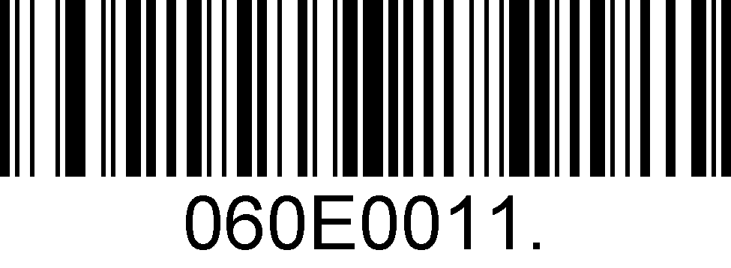
15 – Dutch
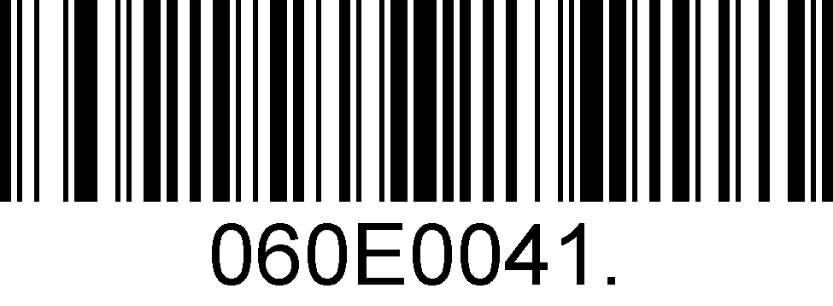
16 – Estonia
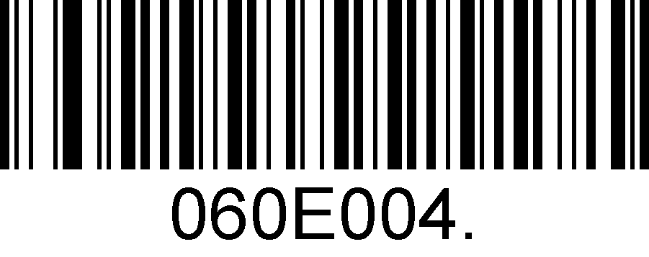
17 – Germany
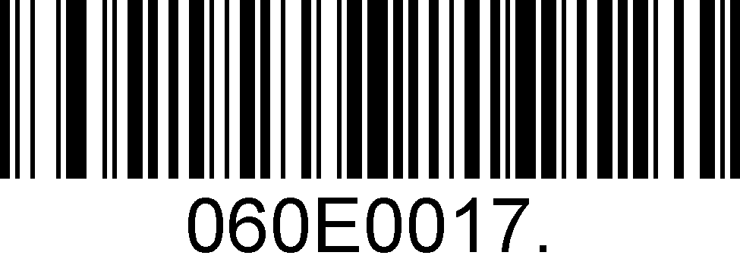
18 – Greek
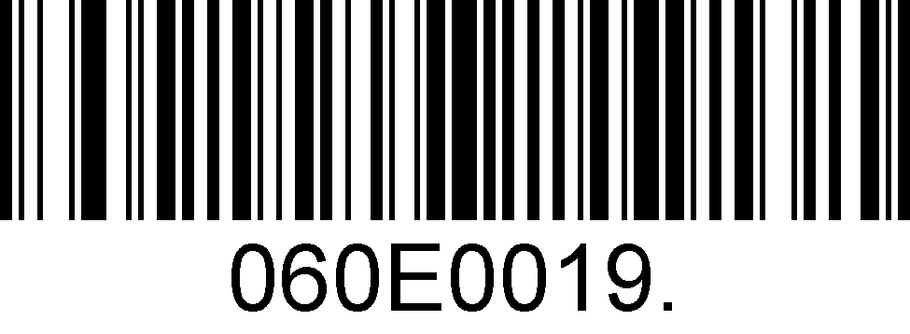
19 – Hungary
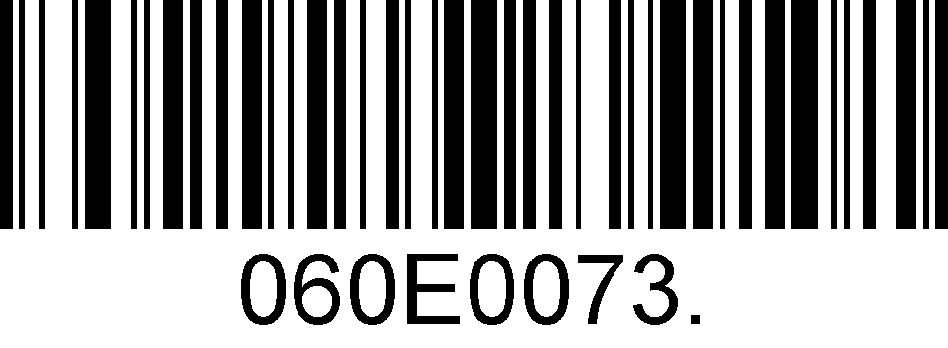
20 – Irish
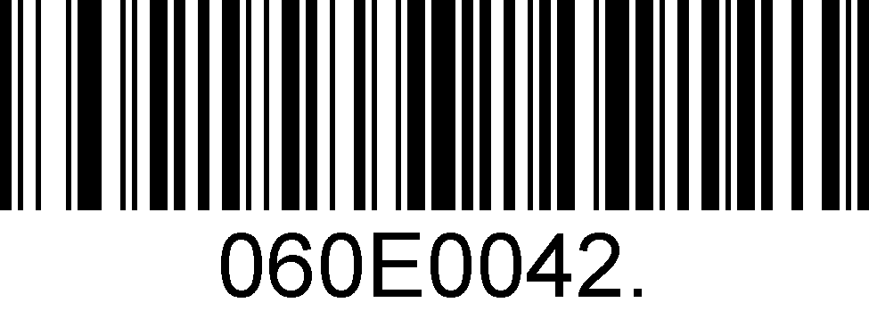
21 – Latvia
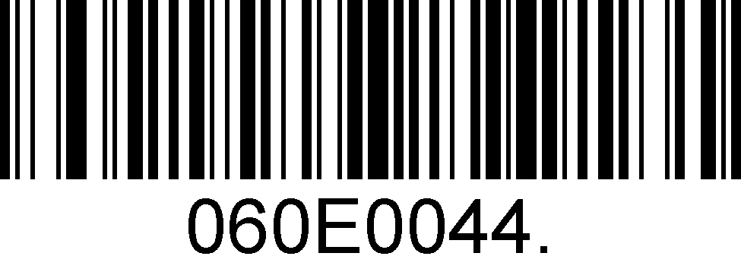
22 – Lithuania
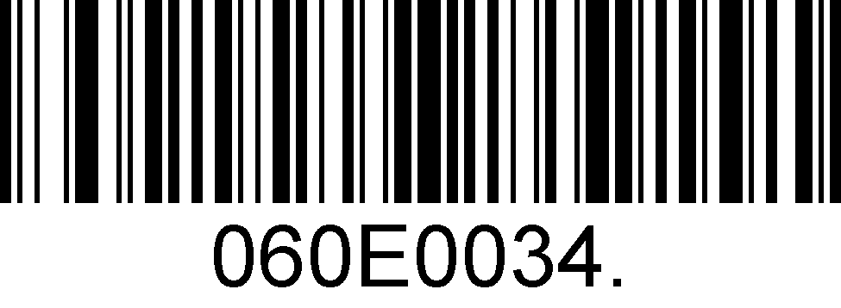
23 – Macedonia
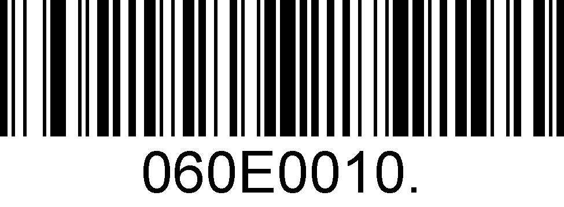
24 – Spain
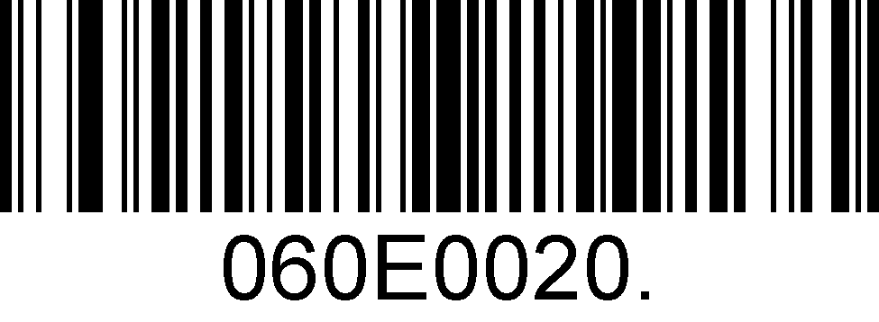
25 – Poland
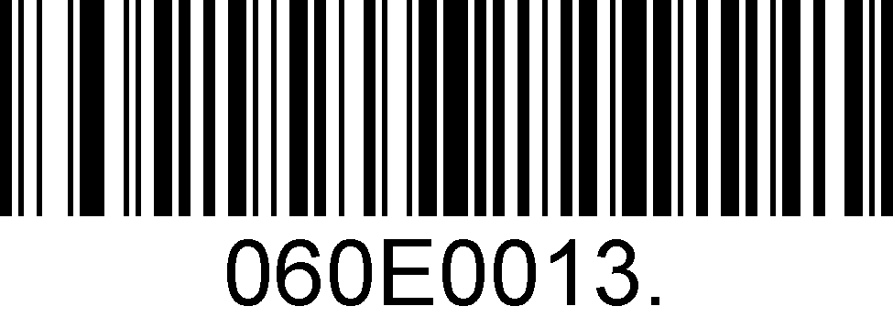
26 – Portugal
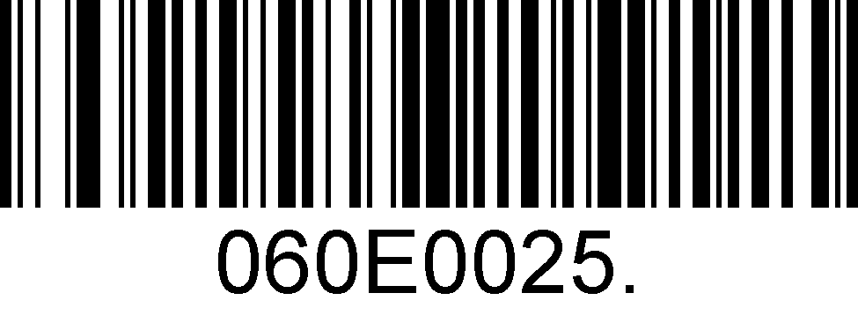
27 – Romania
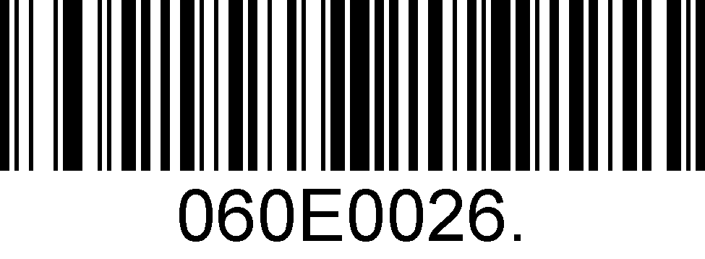
28 – Russia
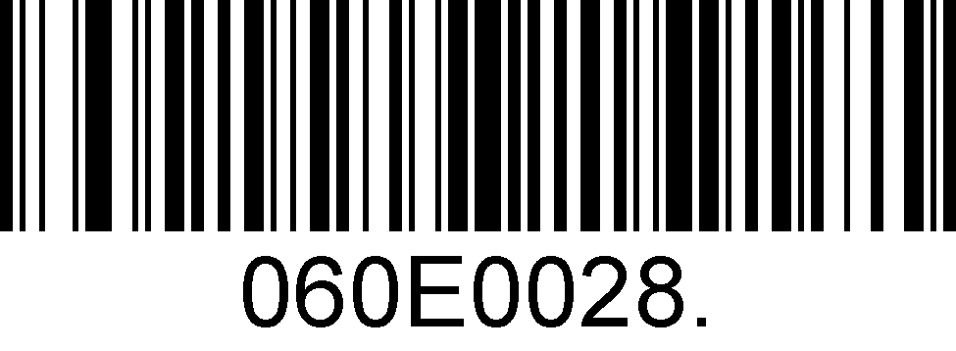
29 – Japan

Convert Case
Scan the appropriate barcode below to convert barcode data to your desired case.

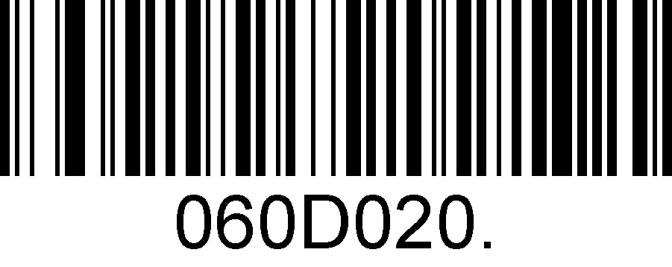
*No Case Conversion
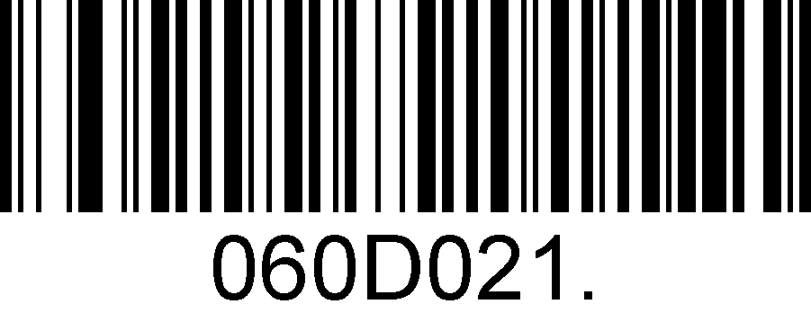
Convert All To Upper Case
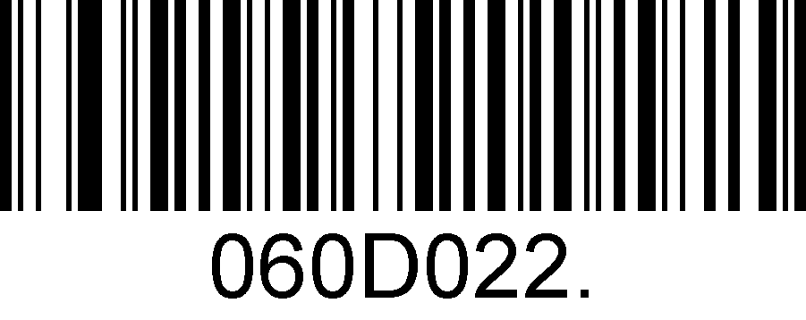
Convert All To Lower Case

Example: When the Convert All to Lower Case feature is enabled, barcode data “AbC” is transmitted as “abc”.

Transmission speed
If the terminal drops characters, change the speed to low.

High

* Medium

low

Function Code Transmit
All ASCII control characters are translated into CTRL+ASCII functions if you enable Function Code Transmit.
Otherwise, they are translated into predefined keystrokes.
Refer to Appendix2: ASCII Table for hexadecimal values of characters.

Ctrl+ ASCII functions Disable

Ctrl+ ASCII functions Enable

USB COM Port Emulation
If you connect the engine to the Host via a USB connection, the USB COM Port Emulation feature allows the Host to receive data in the way as a serial port does. A driver is required for this feature, visit the official website (www.superlead.com) to download and install .

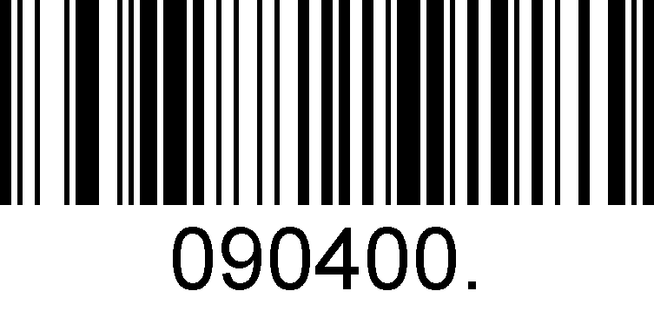
USB COM Port Emulation

General Configuration

Trigger Mode
If the Trigger Mode is enabled, you could activate the scanner by providing an external hardware trigger, or using a serial trigger command. When in manual trigger mode, the scanner scans until a barcode is read, or until the hardware trigger is released. When in serial mode, the scanner scans until a barcode has been read or until the deactivate command is sent.

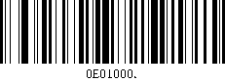
Manual Trigger Mode – Normal

Serial Trigger Command:
Command Trigger: | [0x02][0xF4][0x03]
Command Untrigger: | [0x02][0xF5][0x03]

Auto Sense
Scan the follow barcode can configure the Auto sense, if Auto sense enable, then putting barcode reader on the Cradle is Presentation mode and taking it off is Trigger mode.


Enable

*Disable

Presentation Mode
This sets the scanner to work in presentation mode.

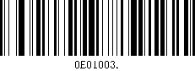
Presentation Mode

Illumination Lights
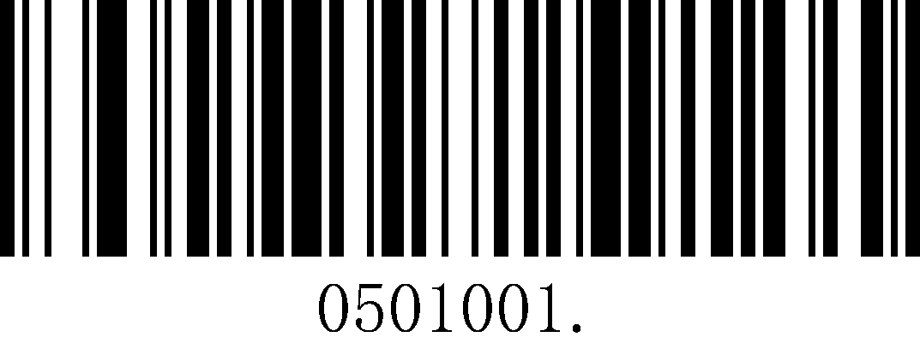
ON
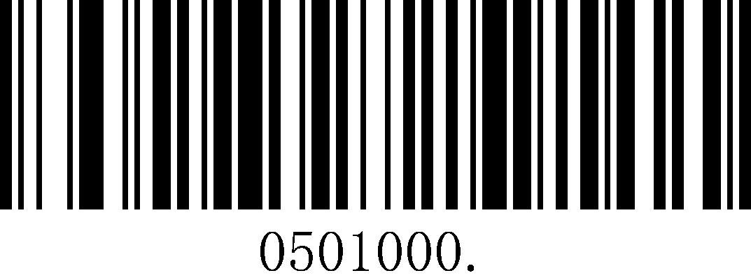
Off

Illumination-Manual Trigger

*High
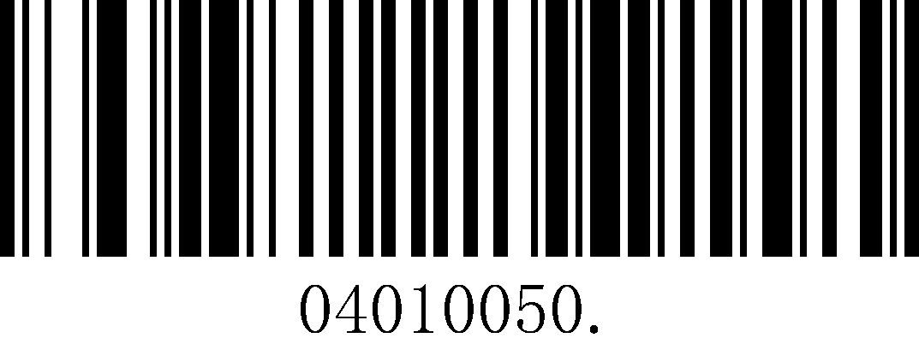
Low

Illumination-Presentation

*High
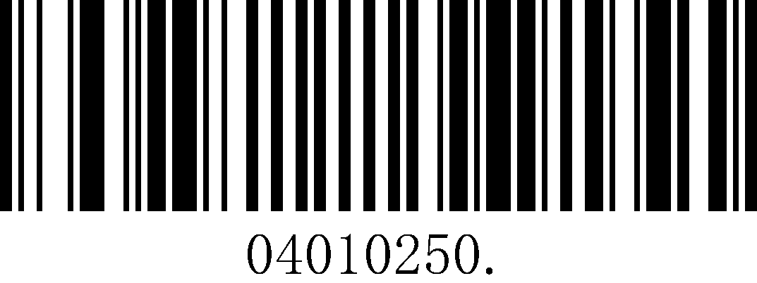
Low

Idle Illumination-Presentation

High

*Low

LED Idle State-Presentation
This sets LED behavior when the scanner is idle.
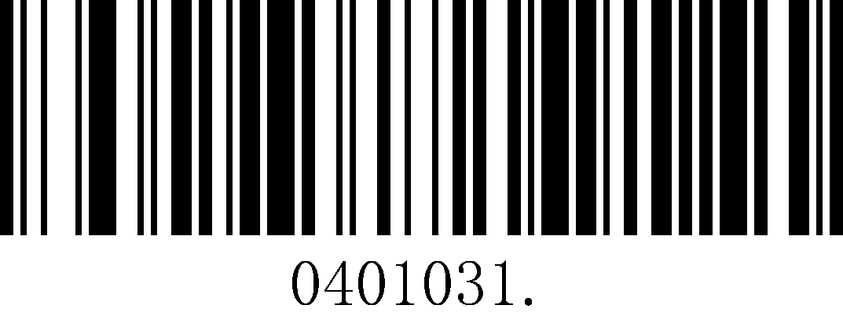
*Leds Off
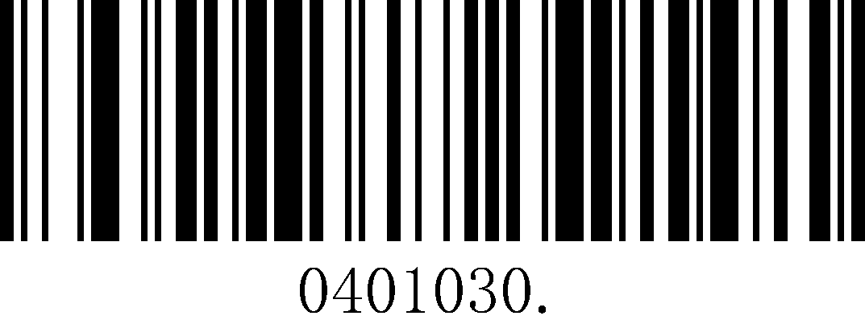
Leds On

Continue-Scan Presentation Mode
This sets the scanner to work in ready all the time.


Continue-Scan Mode

Power-Up Beeper

*ON
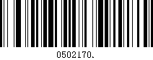
OFF

Good Read Beeper
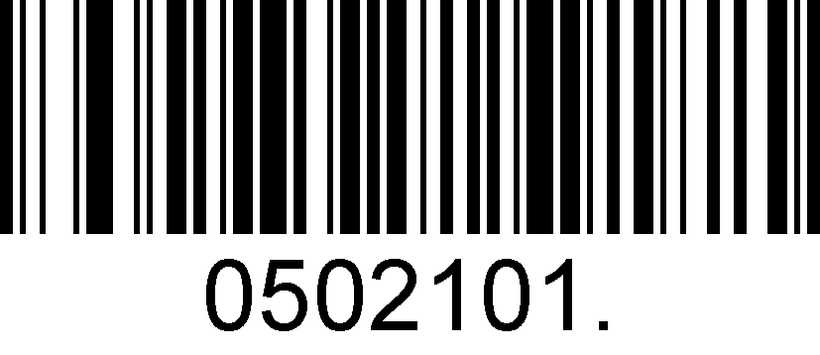
*ON
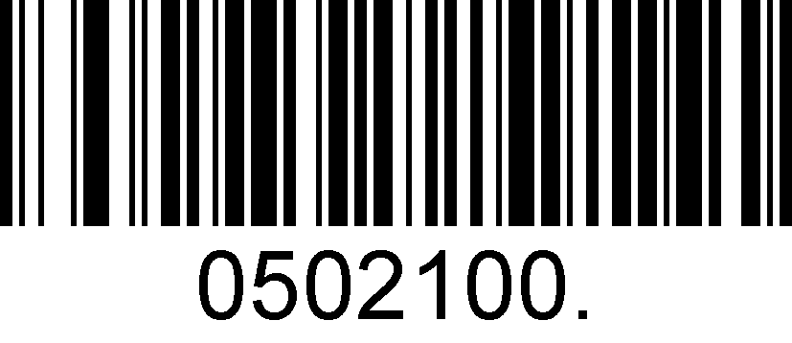
OFF

Good Read Beeper Volume
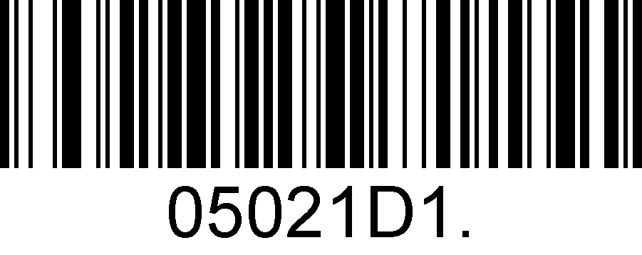
Low
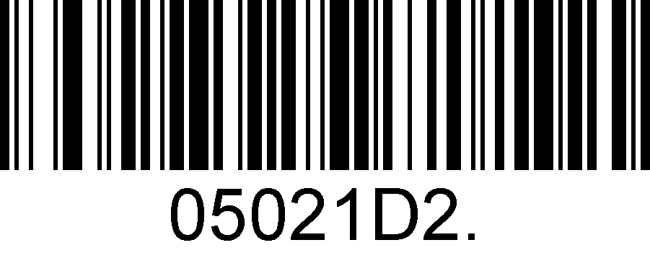
Middle
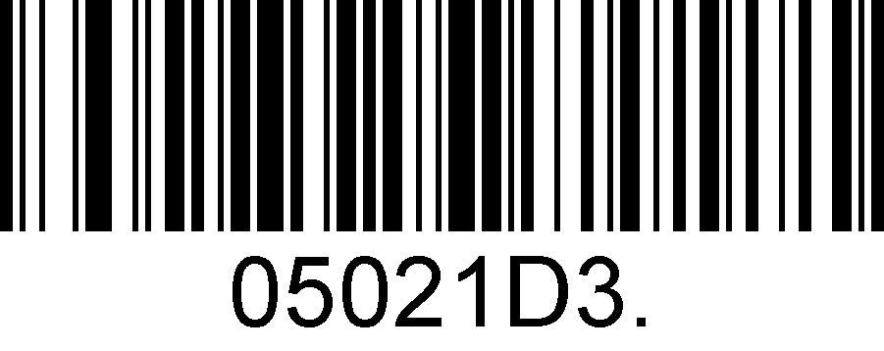
*High

Good Read Beeper Duration
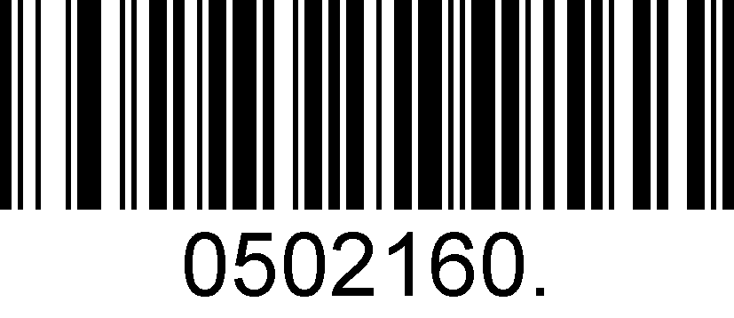
*Normal
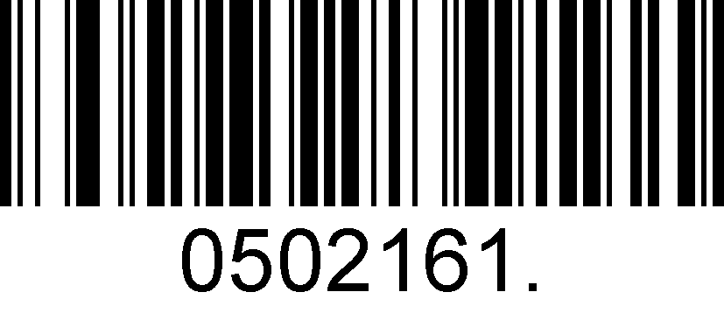
Short

Good Read Beeper Tone

Low Frequency

*Medium Frequency

Medium High Frequency

High Frequency

Vibrate-Good Read
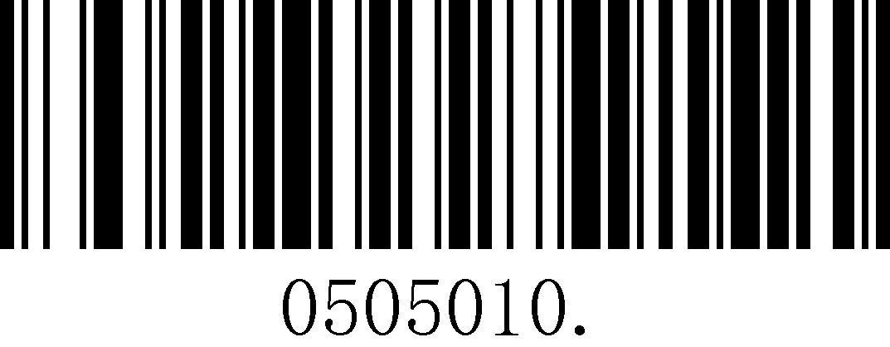
Vibrate-Good Read Off
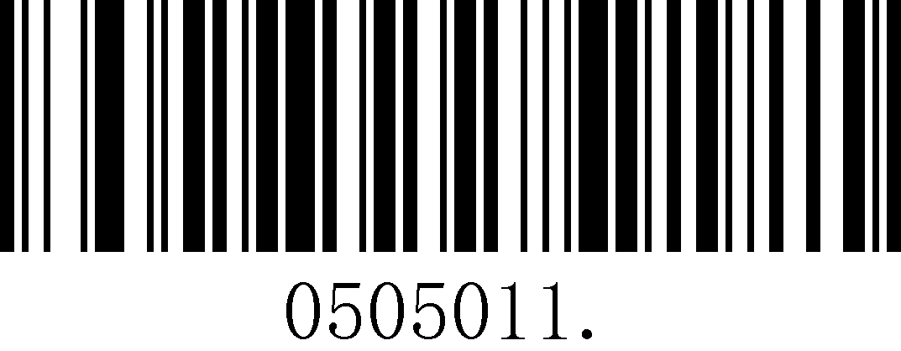
*Vibrate-Good Read On

Good-read Delay
This sets a re-read delay time between decodes of different symbols.
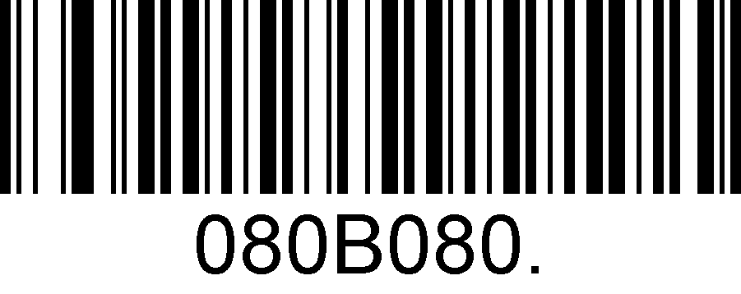
*No Delay
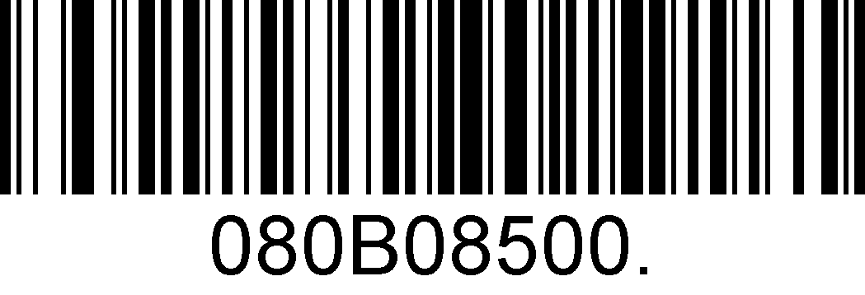
Delay 500 MS
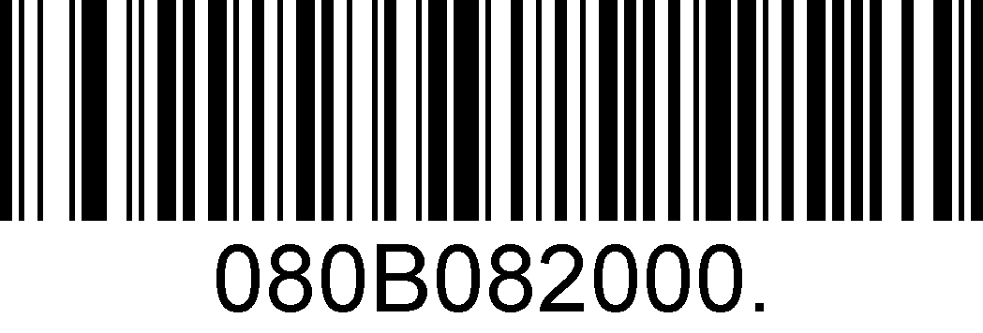
Delay 2000 MS

Reread Delay
This sets a re-read delay time between decodes of the same symbol.

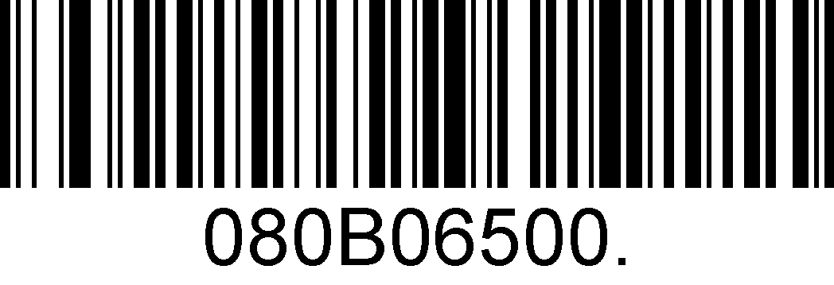
*Delay 500 MS
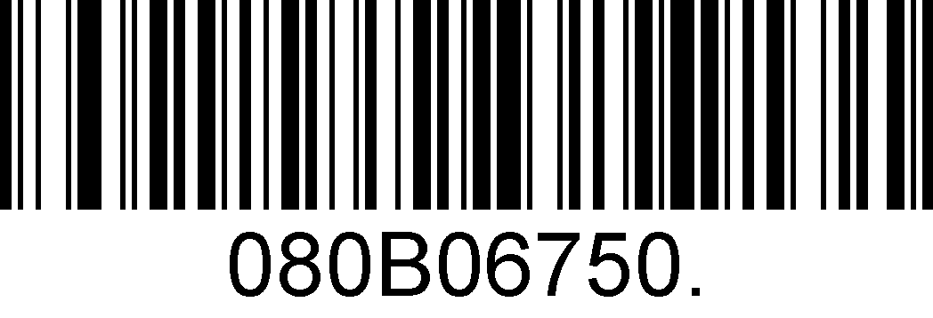
Delay 750 MS
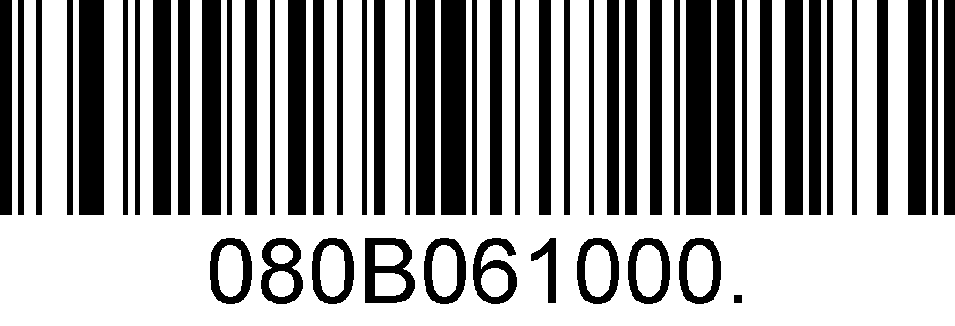
Delay 1000 MS

Accepting RS-232 Commands
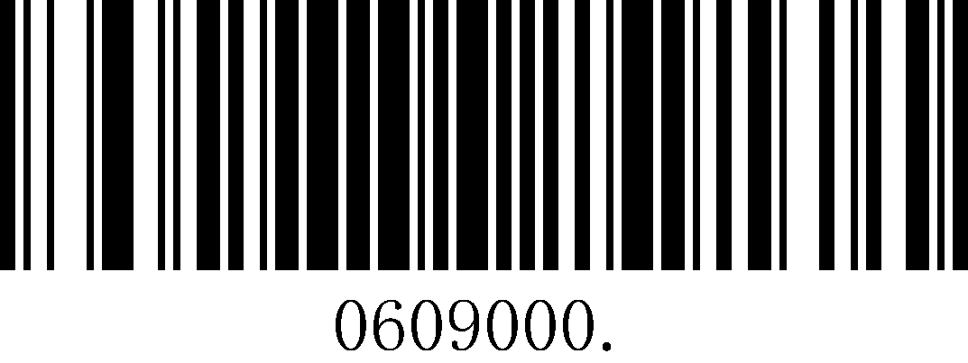
*Disable
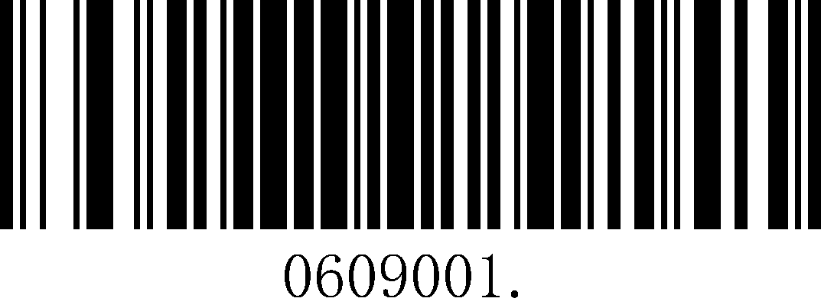
Enable

Commands | ASCII | HEX
Disable Scanner | D | 0x44
Enable Scanner | E | 0x45

For the superlead scanner, it can accept serial host commands. If you wish to enable/disable scanner by using commands, scan the enable barcode. Host commands for other interfaces are also available.
Default =Disable

Data Formatting

General Configuration

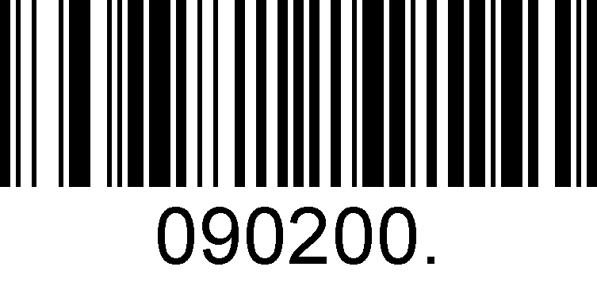
*Add CR
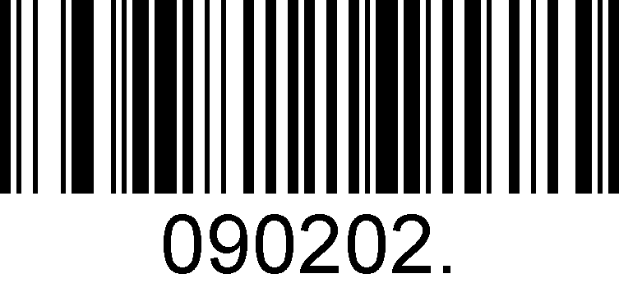
Add LF
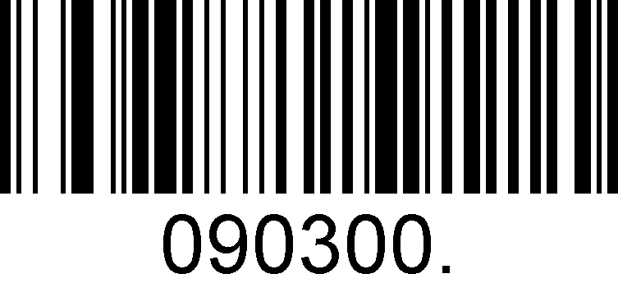
Add CRLF

Add TAB

Add Prefix

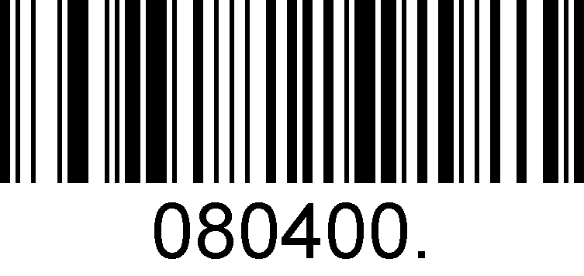
Set Custom Prefix

Save
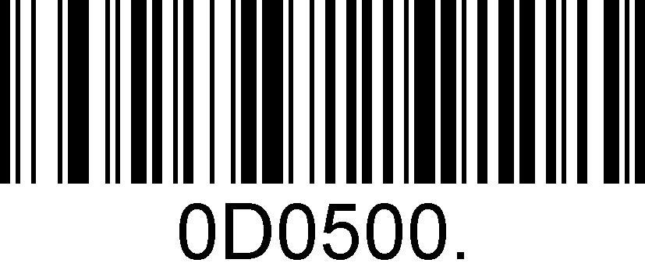
Not Save

To set a customer prefix, scan the Set Custom Prefix barcode and the numeric barcodes which representing the hexadecimal values of a desired prefix, and then scan the Save barcode. Refer to Appendix 2: ASCII Table for hexadecimal values of characters.
Example: Set the custom Prefix to “ODE”
1. Check the hex values of “ODE” in the ASCII Table. (“ODE”: 4F, 44, 45)
2. Scan the Set Custom Prefix barcode.
3. Scan the numeric barcodes”9”,”9”,“4”,“F”,“4”,“4”,“4”and“5”in Appendix 3 .
4. Scan the Save barcode.
Note: 99 indicates all symbollogies

Add Suffix

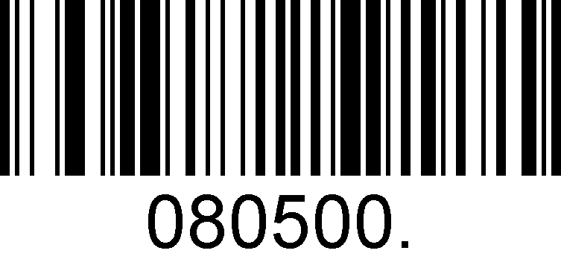
Set Custom Suffix
Save
Not Save

To set a customer suffix, scan the Set Custom Suffix barcode and the numeric barcodes which representing the hexadecimal values of a desired suffix, and then scan the Save barcode. Refer to Appendix 2: ASCII Table for hexadecimal values of characters.
Example: Set the custom Suffix to “ODE”
1. Check the hex values of “ODE” in the ASCII Table. (“ODE”: 4F, 44, 45)
2. Scan the Set Custom Suffix barcode.
3. Scan the numeric barcodes”9”,”9”,“4”,“F”,“4”,“4”,“4”and“5”in Appendix 3 .
4. Scan the Save barcode.
Note: 99 indicates all symbollogies

Clear All Prefix and Suffix
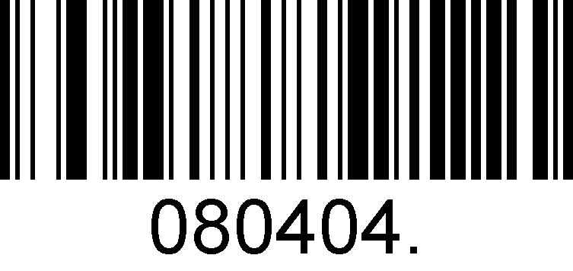
Clear All Prefix And Suffix

Symbologies

General Setting
If the Disable All Symbologies feature is enabled, the engine will not be able to read any non-programming barcodes except the programming barcodes.

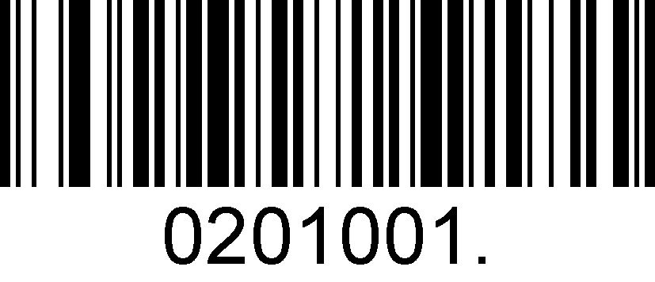
Enable All Symbologies
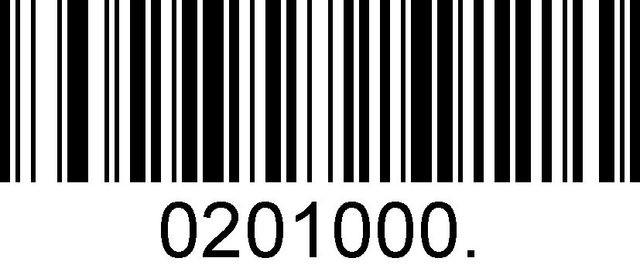
Disable All Symbologies

1D Symbologies

Code 128
Enable/Disable Code 128

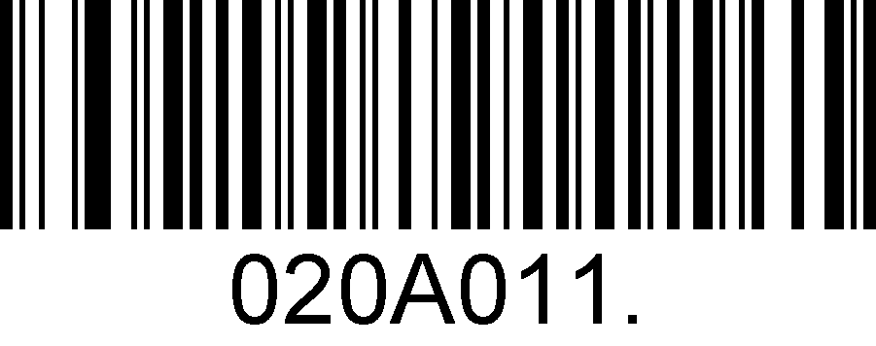
Enable Code 128

Disable Code 128

Message Length for Code 128
Message length can be set to the maximum value or minimum value. The value between the maximum and the minimum is valid.
Code 128 max length command: 020A03. The parameter of this command can be set from min to 90.
Code 128 min length command: 020A02. The parameter of this command can be set from 0 to max.

Set the Maximum Length

Set the Minimum Length

Example: Set the Barcode Message length of the minimum value is 10; the maximum value is 25:
1. Scan the Set the Maximum Length barcode.
2. Scan the numeric barcodes”2”and”5”in Appendix 3 .
3. Scan the Set the Minimum Length barcode.
4. Scan the numeric barcodes”1”and”0”in Appendix 3 .

EAN-8
Enable/Disable EAN-8
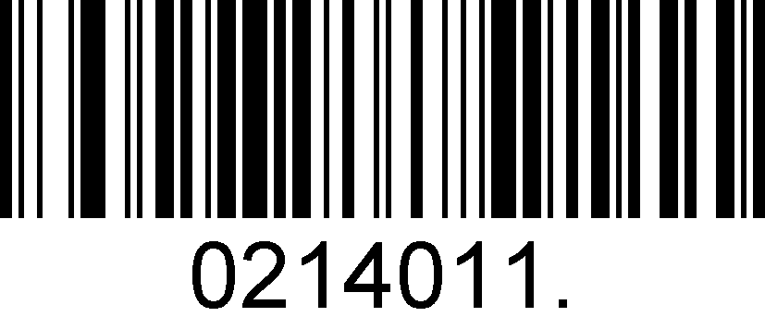
Enable EAN-8
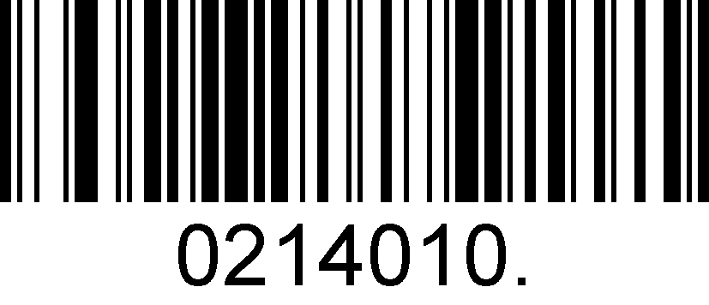
Disable EAN-8
Transmit Check Digit
EAN-8 is 8 digits in length with the last one as its check digit used to verify the accuracy of the data.

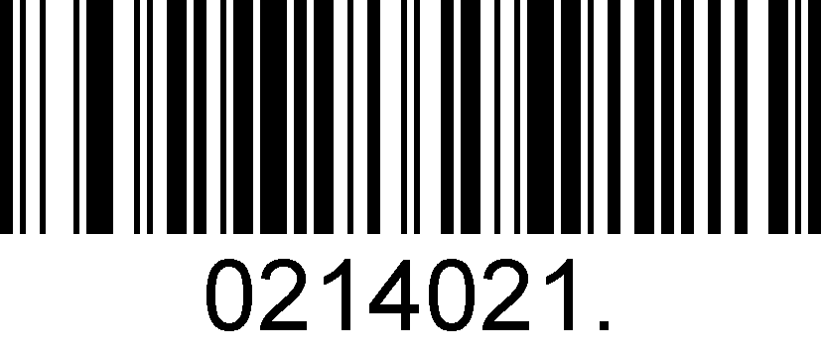
Transmit EAN-8 Check Digit
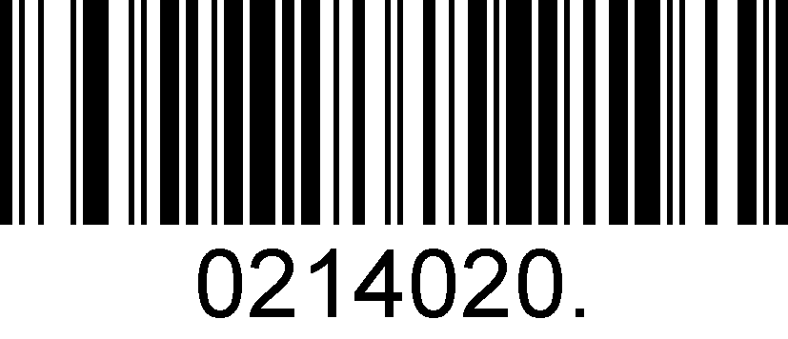
Do Not Transmit EAN-8 Check Digit
Add-On Code
An EAN-8 barcode can be augmented with a two-digit or five-digit add-on code to form a new one. In the examples below, the part surrounded by blue dotted line is an EAN-8 barcode while the part circled by red dotted line is add-on code.

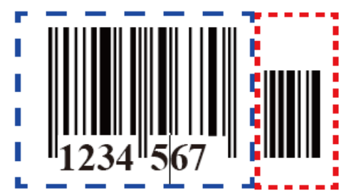 | 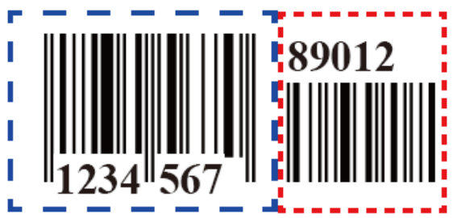
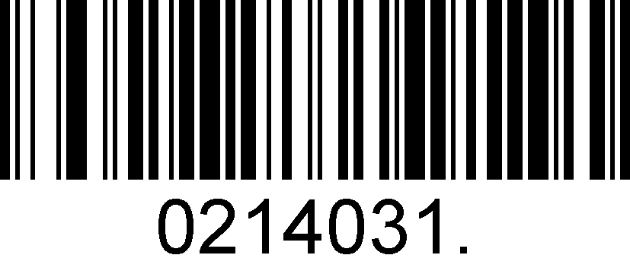
Enable 2-Digit Add-On Code
 | 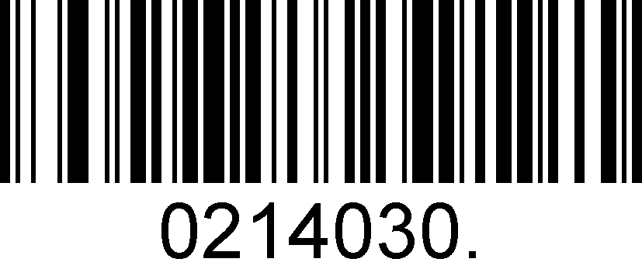
 | Disable 2-Digit Add-On Code
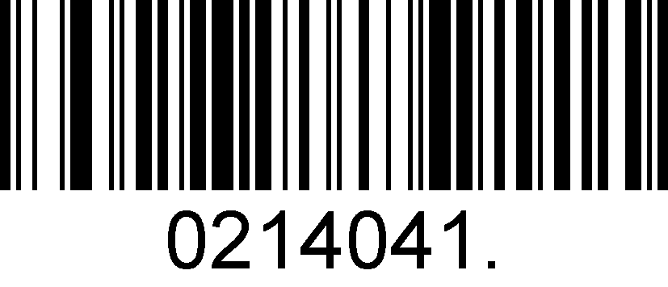
Enable 5-Digit Add-On Code
 | 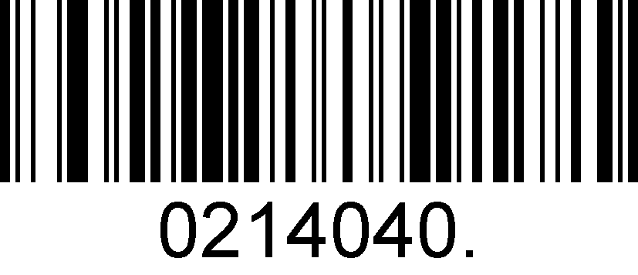
 | Disable 5-Digit Add-On Code

Add-On Code Required
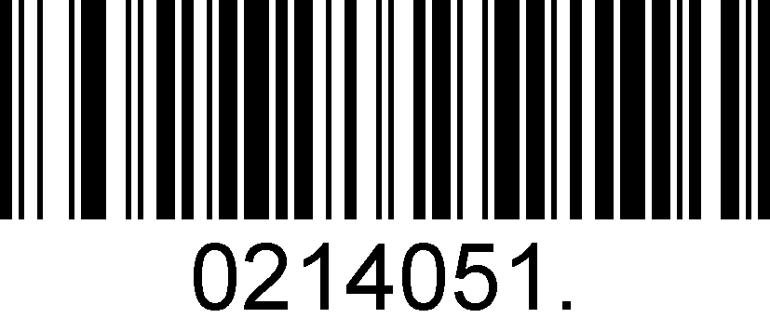
EAN-8 Add-On Code Required
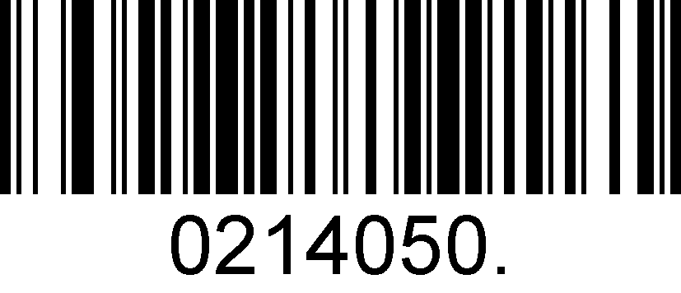
EAN-8 Add-On Code Not Required
ENA/JAN-8 Addenda Separator
When this feature is enabled, there is a space between barcode and addenda. When this feature is disabled, there is no space.

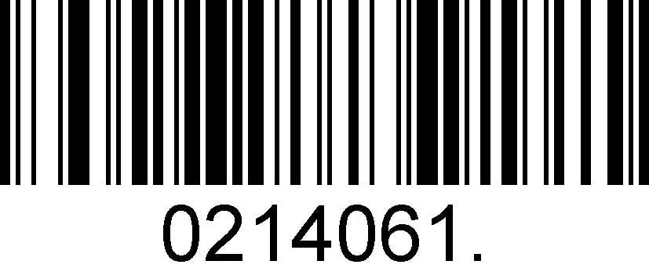
Enable ENA/JAN-8 Addenda Separator
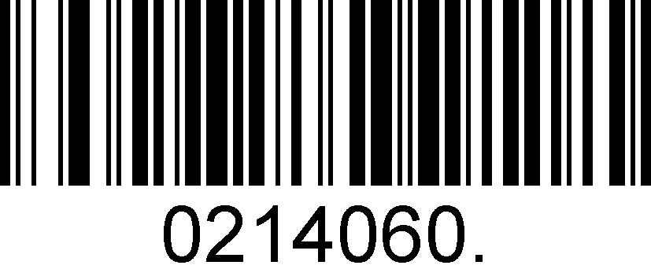
Disable ENA/JAN-8 Addenda Separator UPC

EAN-13

Enable/Disable EAN-13
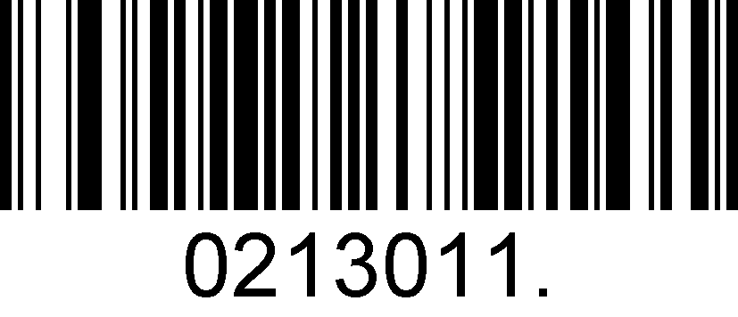
Enable EAN-13
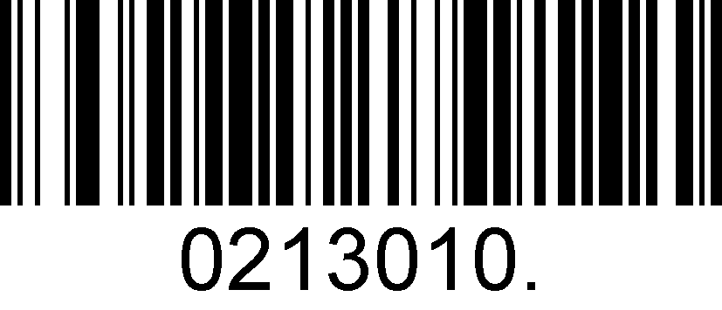
Disable EAN-13
Transmit Check Digit
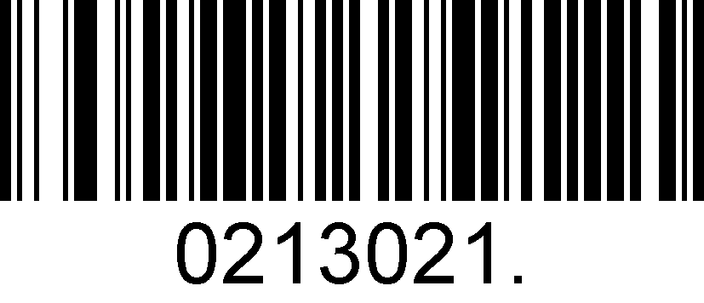
Transmit EAN-13 Check Digit
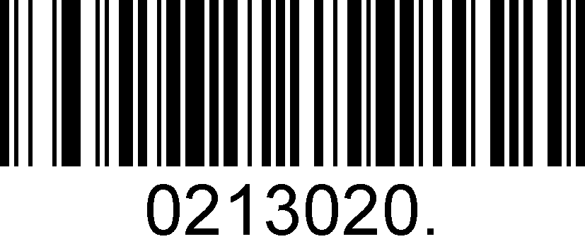
Do Not Transmit EAN-13 Check Digit

Add-On Code
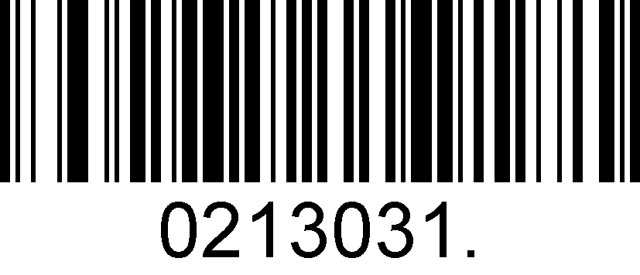
Enable 2-Digit Add-On Code
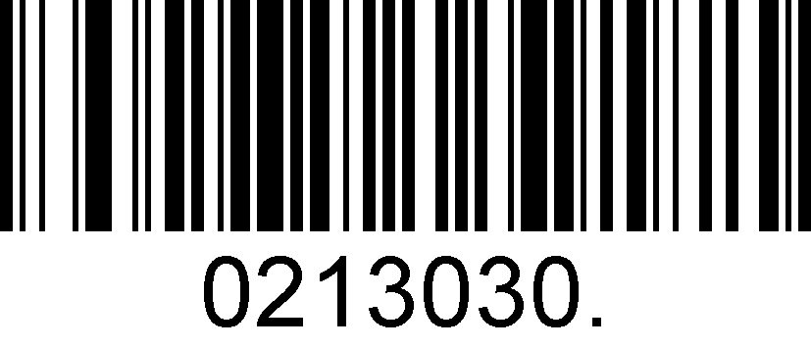
Disable 2-Digit Add-On Code
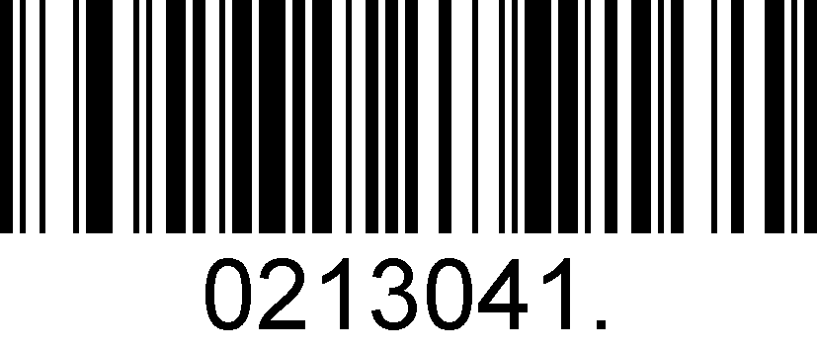
Enable 5-Digit Add-On Code
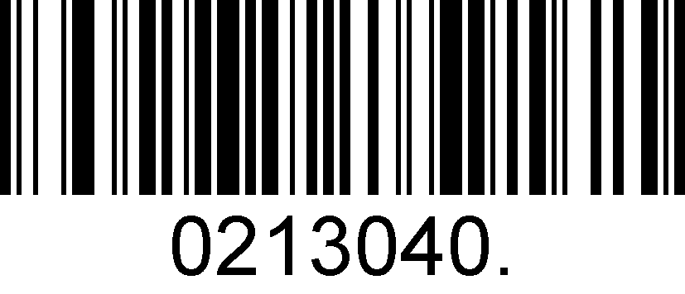
Disable 5-Digit Add-On Code
Add-On Code Required
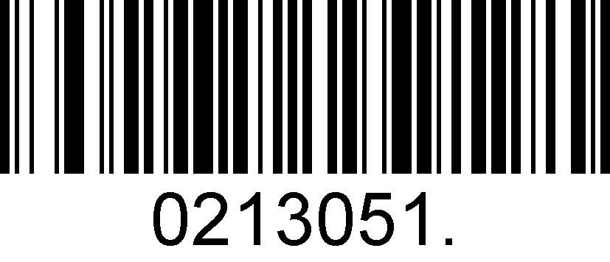
EAN-13 Add-On Code Required
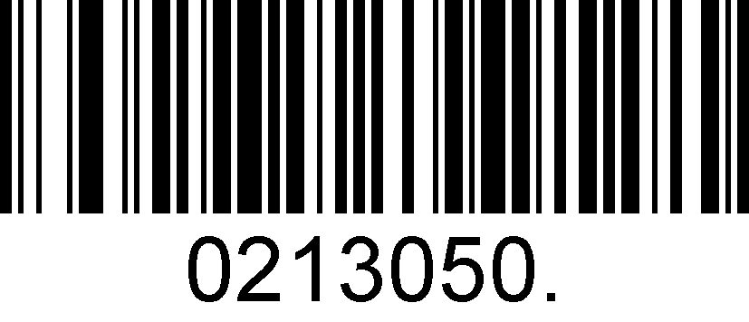
EAN-13 Add-On Code Not Required
ENA/JAN-13 Addenda Separator
When this feature is enabled, there is a space between barcode and addenda. When this feature is disabled, there is no space.

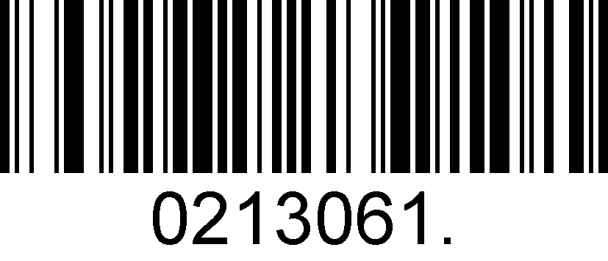
Enable ENA/JAN-13 Addenda Separator
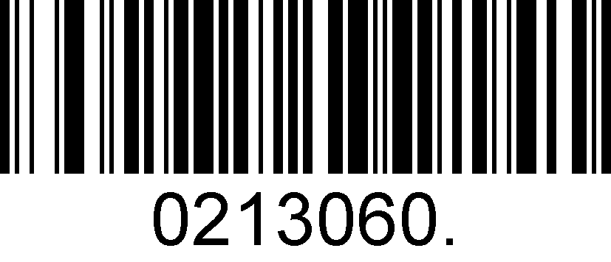
Disable ENA/JAN-13 Addenda Separator

ISBN Translate
When enable this feature and is scanned, EAN-13 Book land symbols are translated into their equivalent ISBN number format.

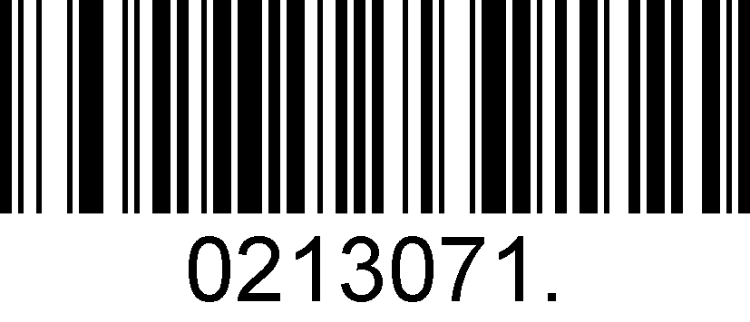
Enable ISBN Translate
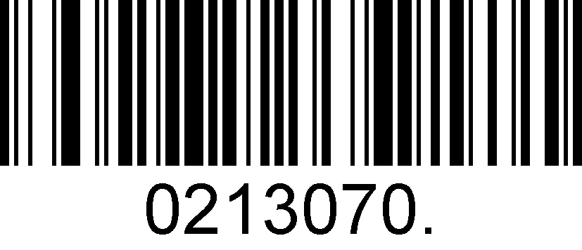
Disable ISBN Translate

UPC-E
Enable/Disable UPC-E0/E1

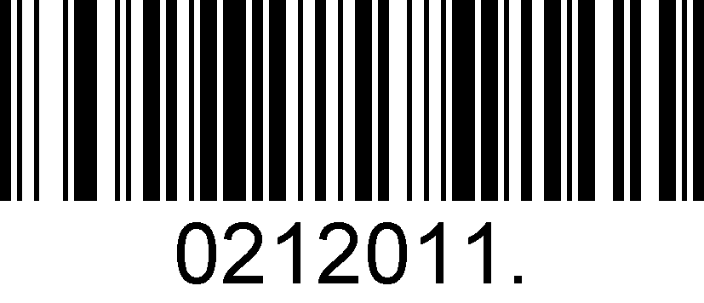
Enable UPC-E0
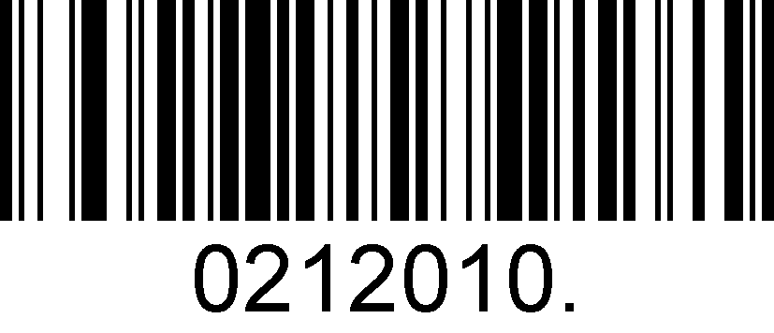
Disable UPC-E0
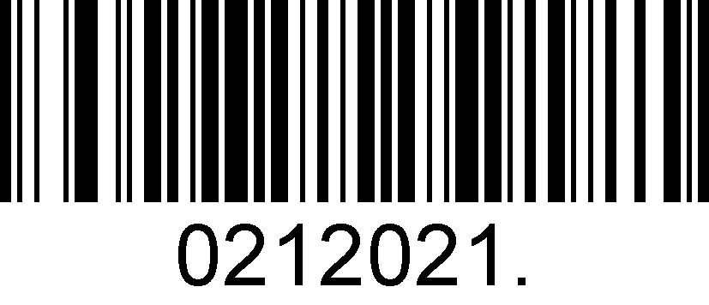
Enable UPC-E1
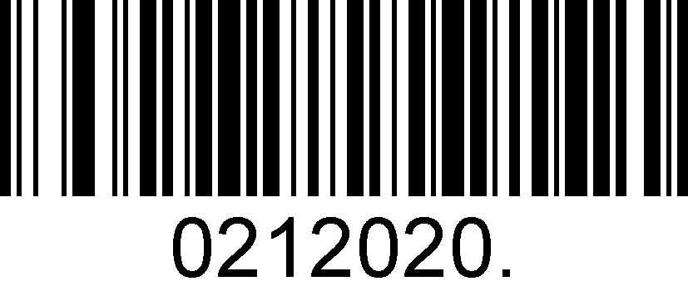
Disable UPC-E1

UPC-E0 Check Digit

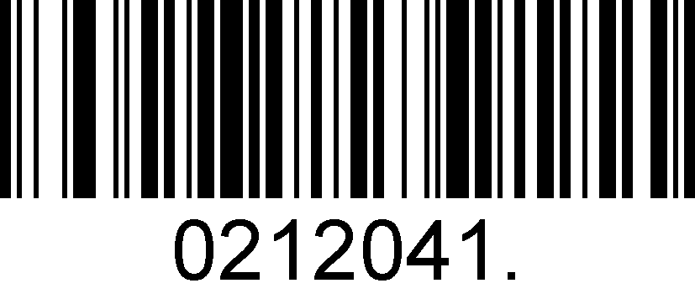
Enable UPC-E0 Check Digit
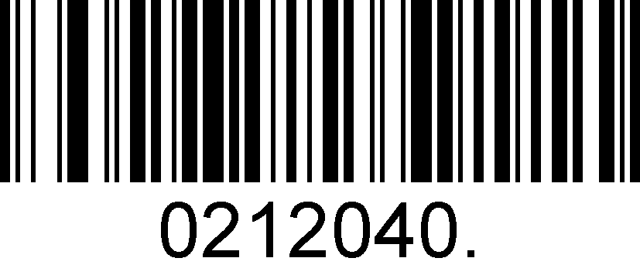
Disable UPC-E0 Check Digit

UPC-E0 Expand
UPC-E0 expand expands the UPC-E code to the 12 digits, UPC-A format.

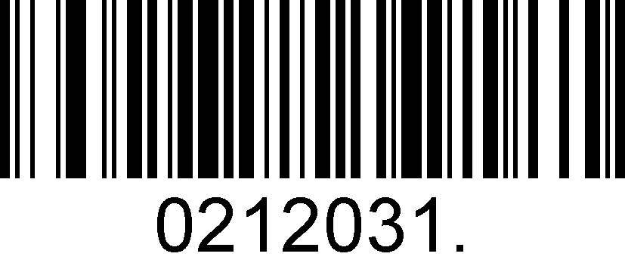
Enable UPC-E0 Expand
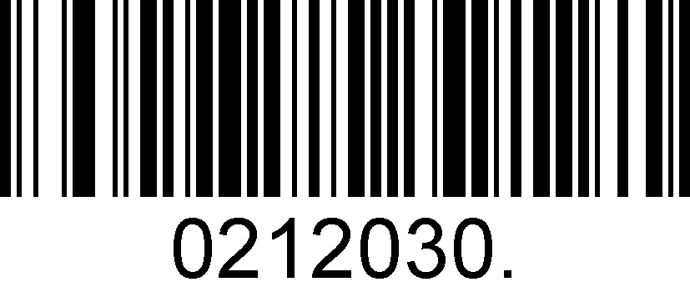
Disable UPC-E0 Expand

UPC-E0 Addenda Required
When required is scanned, the scanner will only read UPC-E barcodes that have addenda.

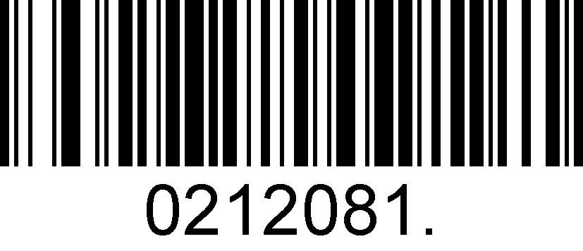
Enable UPC-E0 Required
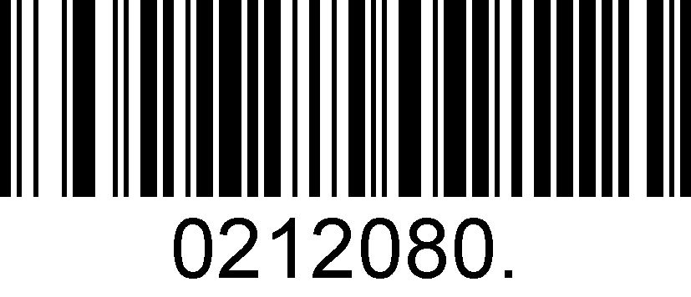
Disable UPC-E0 Required

UPC-E0 Addenda Separator
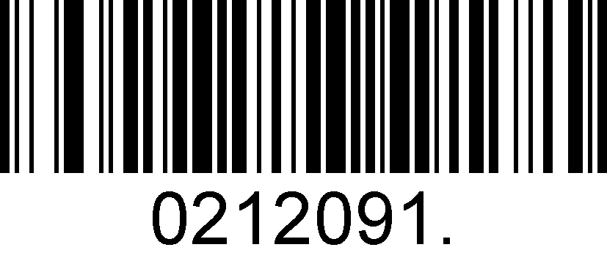
Enable UPC-E0 Separator
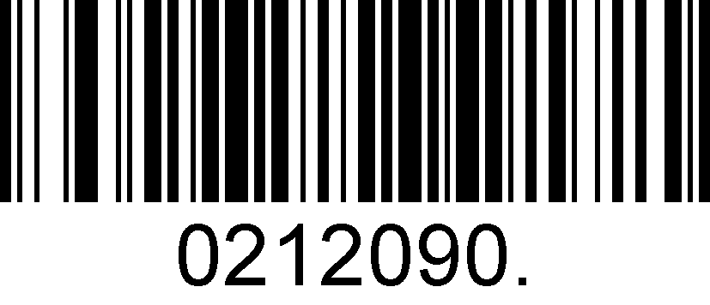
Disable UPC-E0 Separator

UPC-E0 Number System
The number system digit of UPC symbol is normally transmitted at the beginning of the scanned data, but the unit can be programmed so it will be not transmitted.

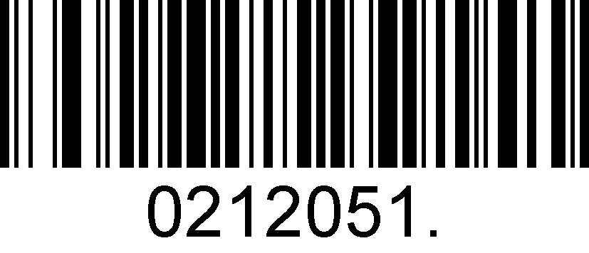
Enable UPC-E0 Number System
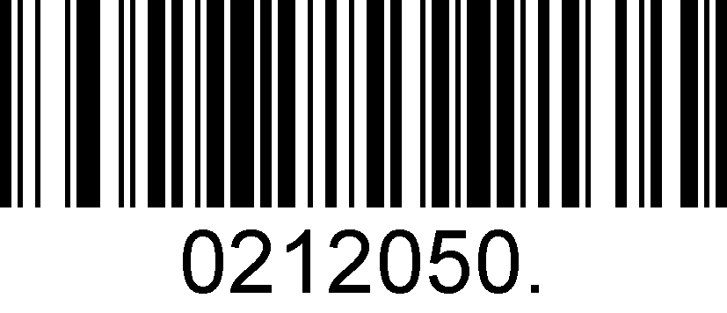
Disable UPC-E0 Number System

UPC-E0 Addenda
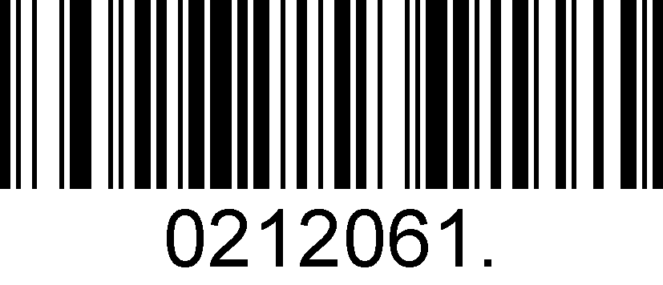
Enable 2 Digit Addenda
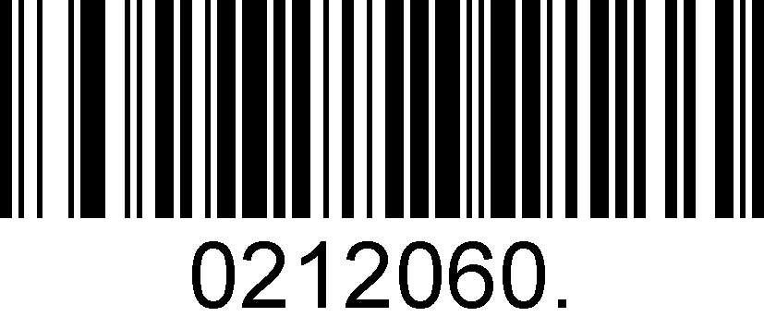
Disable 2 Digit Addenda
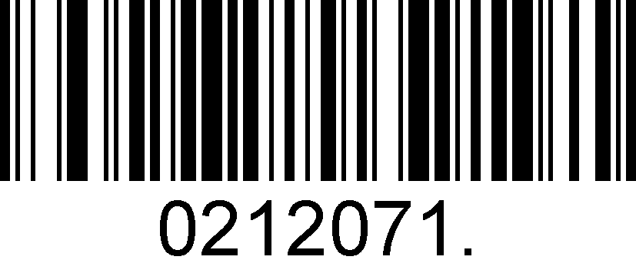
Enable 5 Digit Addenda
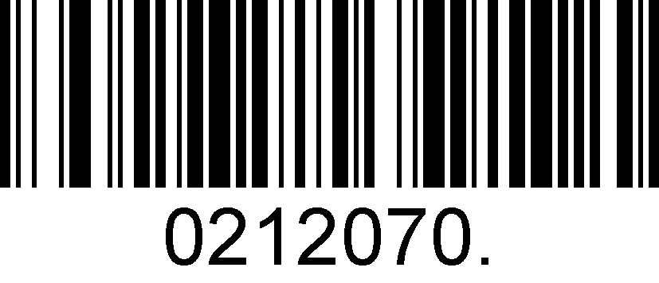
Disable 5 Digit Addenda

UPC-A
Enable/Disable UPC-A
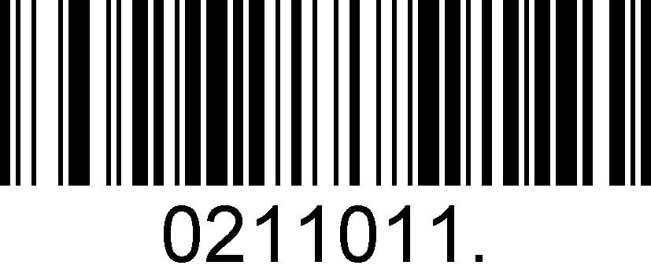
Enable UPC-A
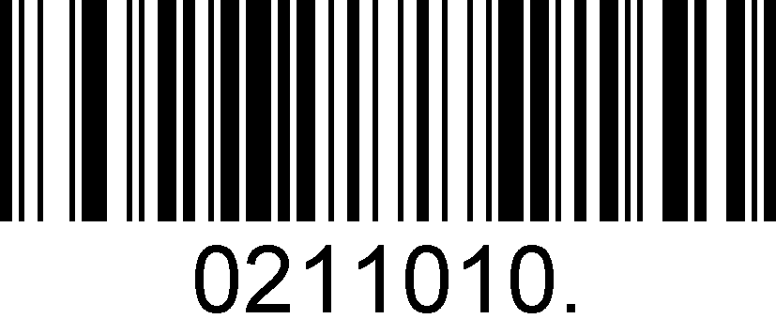
Disable UPC-A

UPC-A Check Digit
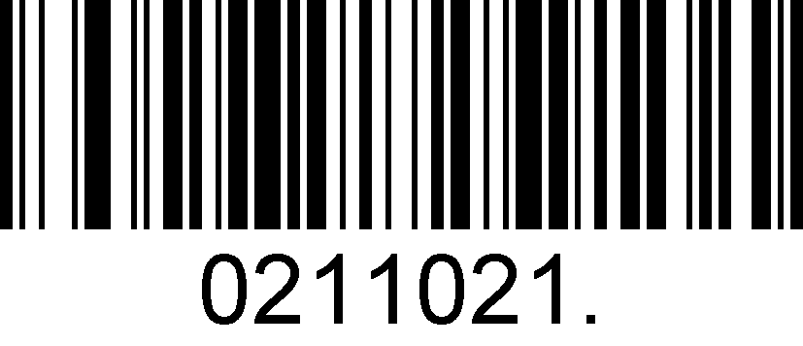
Enable UPC-A Check Digit
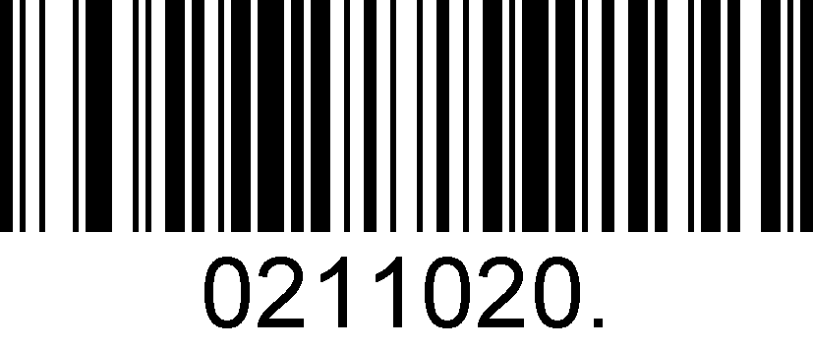
Disable UPC-A Check Digit

UPC-A Addenda Required
When required is scanned, the scanner will only read UPC-E barcodes that have addenda.

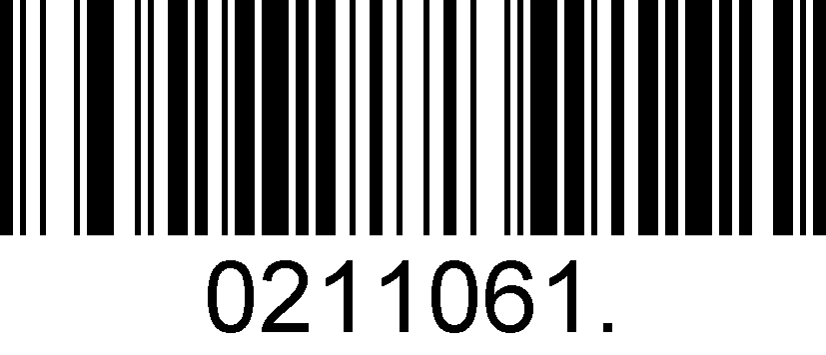
Enable UPC-A Required
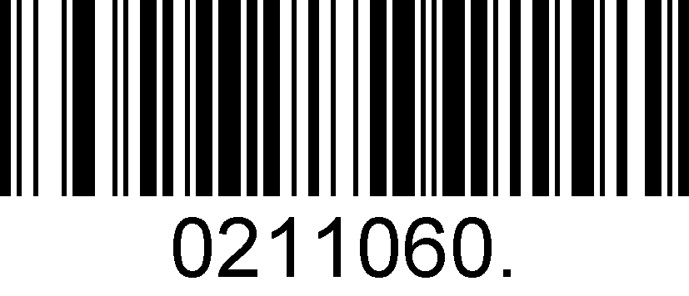
Disable UPC-A Required

UPC-A Addenda Separator

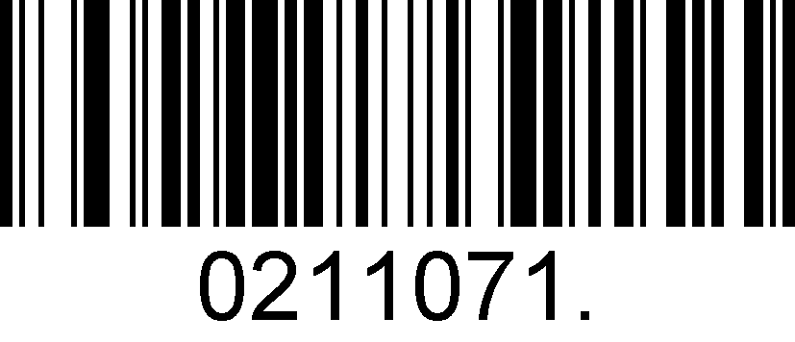
Enable UPC-A Separator
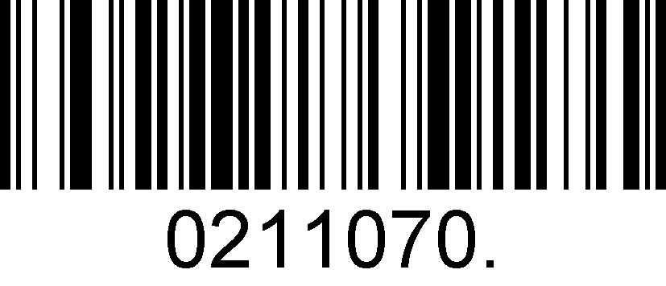
Disable UPC-A Separator

UPC-A: Number System
The number system digit of UPC symbol is normally transmitted at the beginning of the scanned data, but the unit can be programmed so it will be not transmitted.

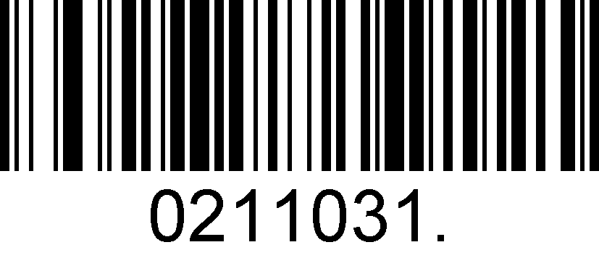
Enable UPC-A Number System
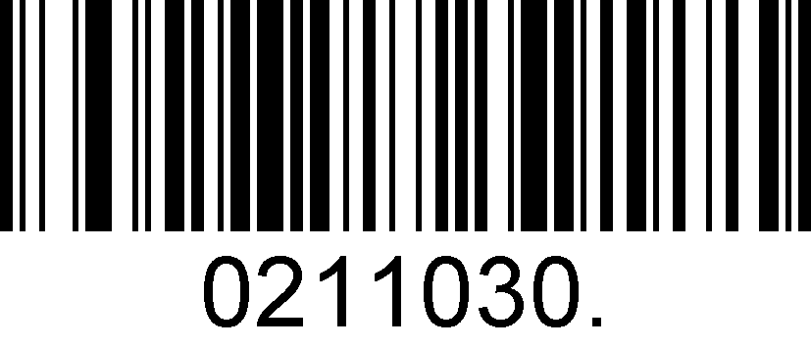
Disable UPC-A Number System

UPC-A: Addenda

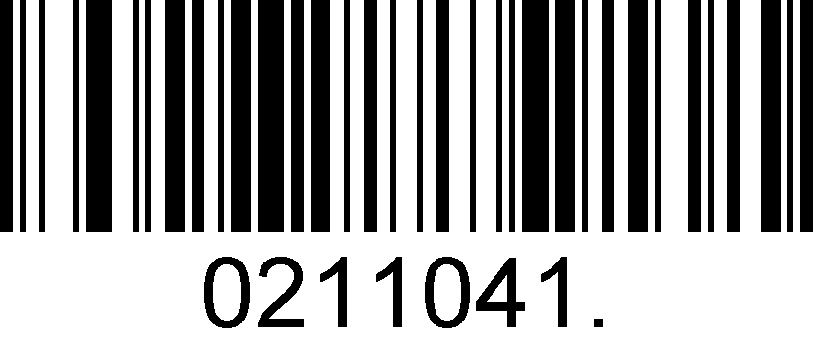
Enable 2 Digit Addenda
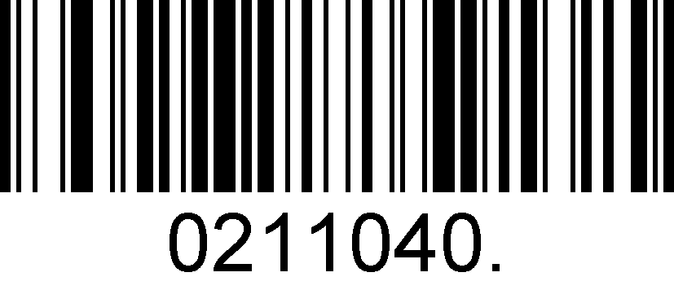
Disable 2 Digit Addenda
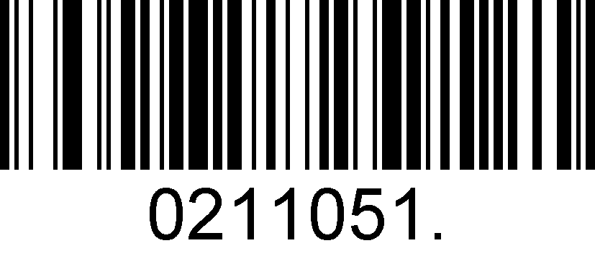
Enable 5 Digit Addenda
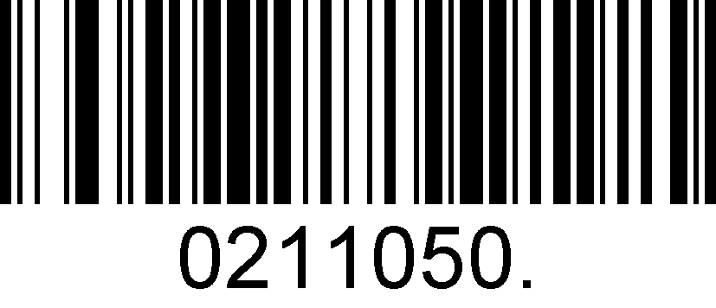
Disable 5 Digit

Interleaved 2 of 5
Enable/Disable Interleaved 2 of 5
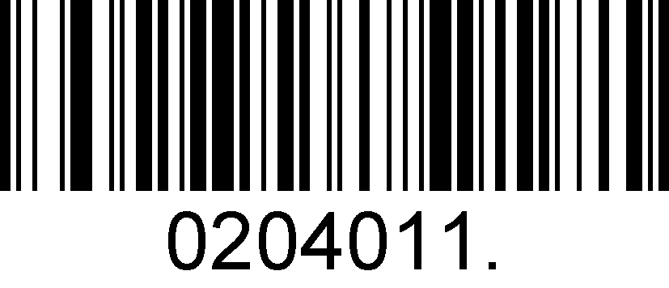
Enable Interleaved 2 of 5

Disable Interleaved 2 of 5
Message Length for Interleaved 2of 5
Message length can be set to the maximum value or minimum value. The value between the maximum and the minimum is valid.
Interleaved 2 of 5 max length command: 020403. The parameter of this command can be set from min to 80.
Interleaved 2 of 5 min length command: 020402. The parameter of this command can be set from 2 to max.
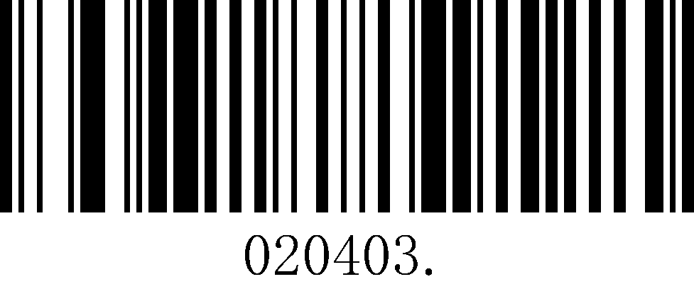
Set the Maximum Length
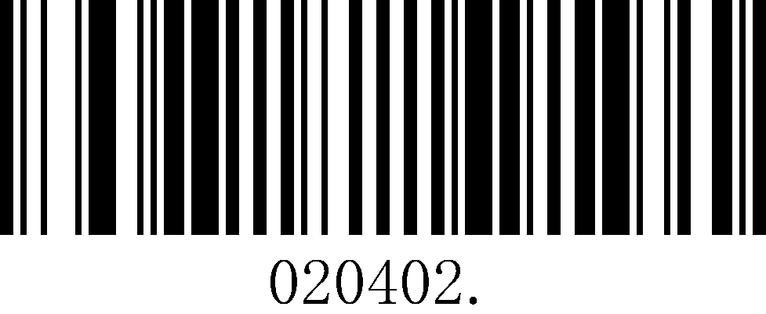
Set the Minimum Length

Example: Set the Barcode Message length of the minimum value is 10; the maximum value is 25:
1. Scan the Set the Maximum Length barcode.
2. Scan the numeric barcodes”2”and”5”in Appendix 3 .
3. Scan the Set the Minimum Length barcode.
4. Scan the numeric barcodes”1”and”0”in Appendix 3 .

Interleaved 2 of 5 Check Digit
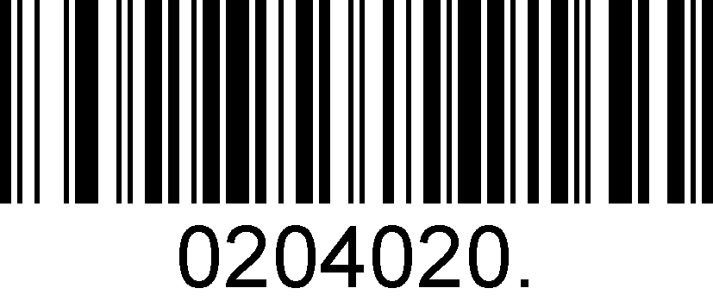
No Check Char
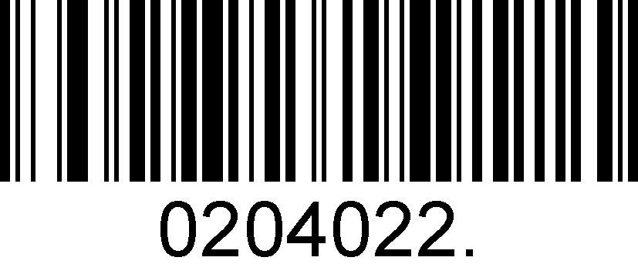
Validate And Transmit
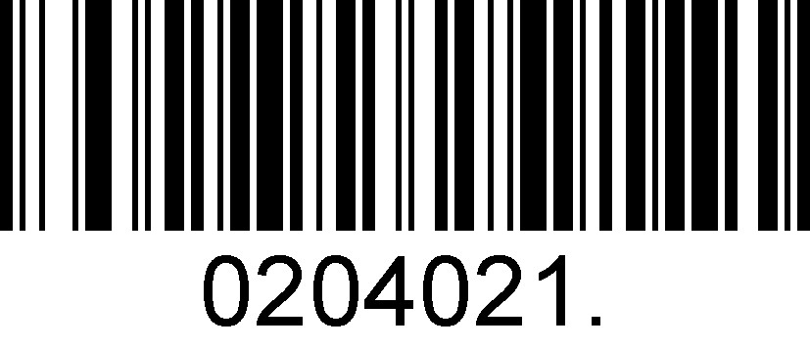
Validate Not Transmit

Matrix 2 of 5

Enable/Disable Matrix 2 of 5
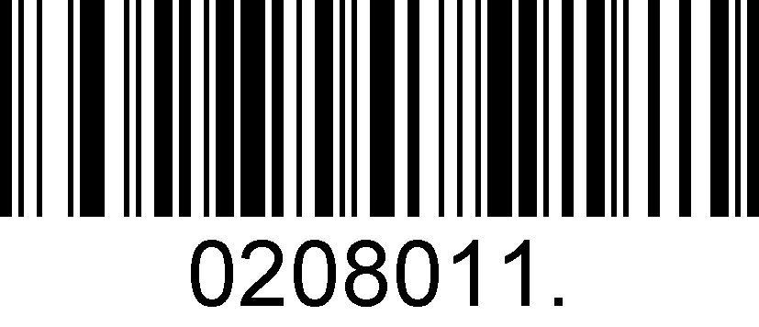
Enable Matrix 2 of 5

Disable Matrix 2 of 5

Message Length for Matrix 2 of 5
Message length can be set to the maximum value or minimum value. The value between the maximum and the minimum is valid.
Matrix 2 of 5 max length command: 020803. The parameter of this command can be set from min to 80.
Matrix 2 of 5 min length command: 020802. The parameter of this command can be set from 1 to max.
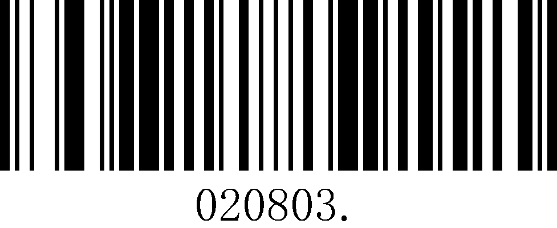
Set the Maximum Length
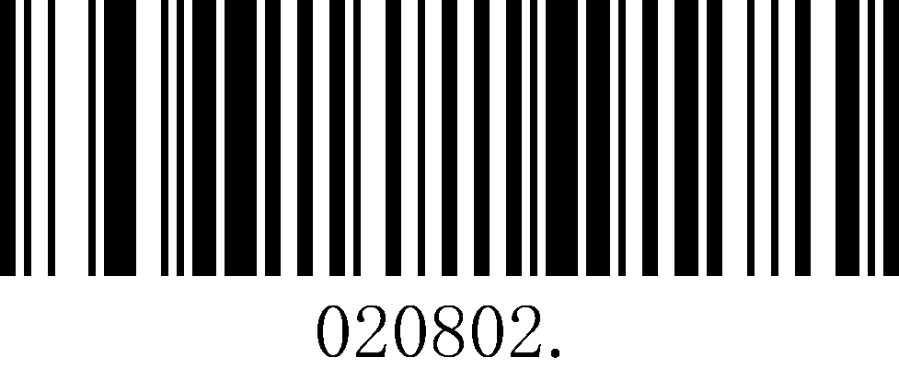
Set the Minimum Length

Example: Set the Barcode Message length of the minimum value is 10; the maximum value is 25:
1. Scan the Set the Maximum Length barcode.
2. Scan the numeric barcodes”2”and”5”in Appendix 3 .
3. Scan the Set the Minimum Length barcode.
4. Scan the numeric barcodes”1”and”0”in Appendix 3 .

Industrial 2 of 5
Enable/Disable Industrial 2 of 5
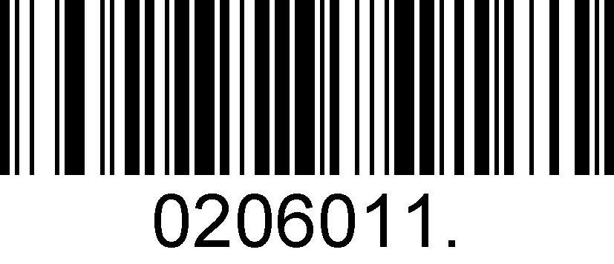
Enable Industrial 2 of 5

Disable Industrial 2 of 5

Message Length for Industrial 2 of 5
Message length can be set to the maximum value or minimum value. The value between the maximum and the minimum is valid.
Industrial 2 of 5 max length command: 020603. The parameter of this command can be set from min to 80.
Industrial 2 of 5 min length command: 020602. The parameter of this command can be set from 1 to max.
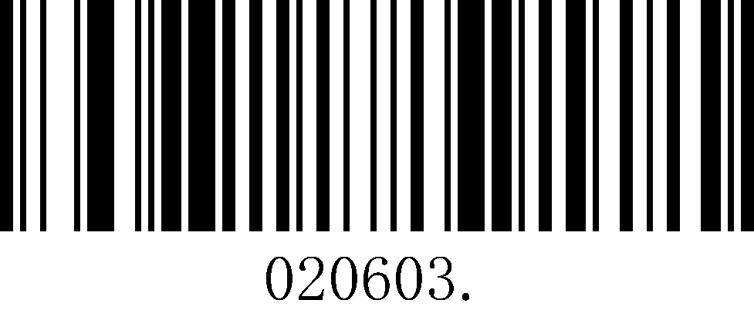
Set the Maximum Length
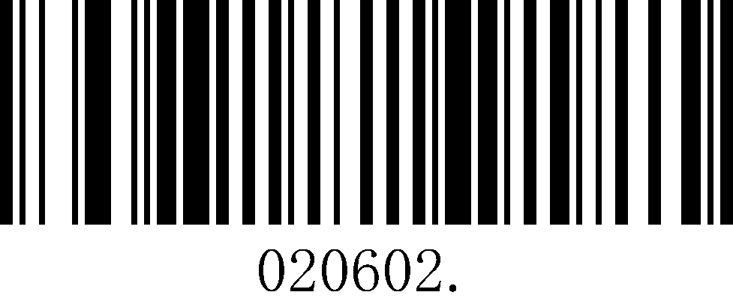
Set the Minimum Length

Example: Set the Barcode Message length of the minimum value is 10; the maximum value is 25:
1. Scan the Set the Maximum Length barcode.
2. Scan the numeric barcodes”2”and”5”in Appendix 3 .
3. Scan the Set the Minimum Length barcode.
4. Scan the numeric barcodes”1”and”0”in Appendix 3 .

Code 39
Enable/Disable Code 39
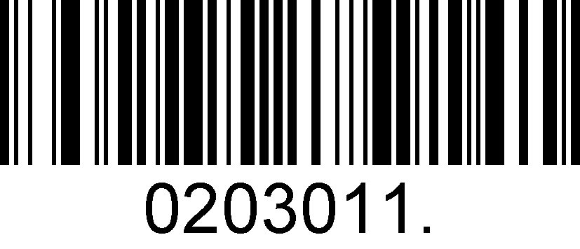
Enable Code 39

Disable Code 39

Transmit Start/Stop Character
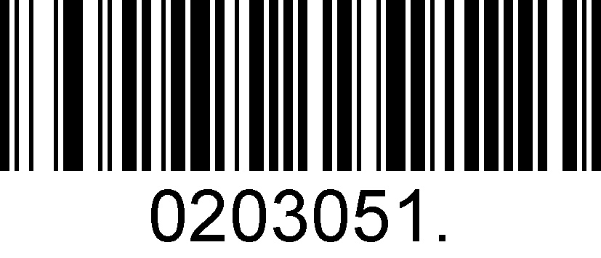
Transmit Start/Stop Character
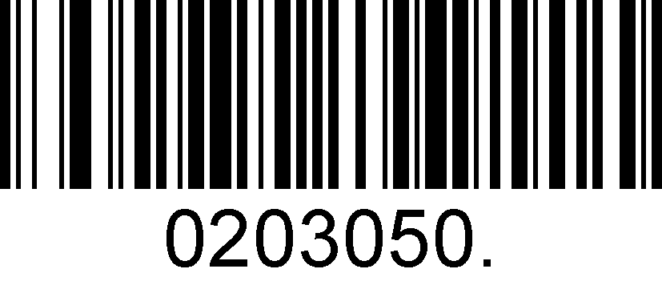
Do Not Transmit Start/Stop Character

Code 39 Check Character
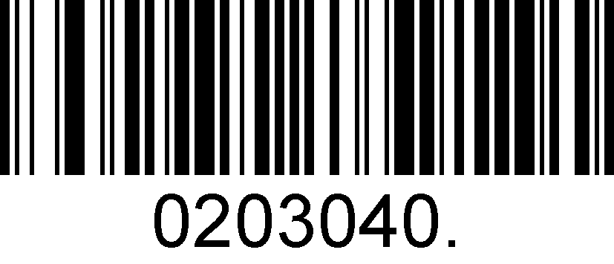
No Check Char
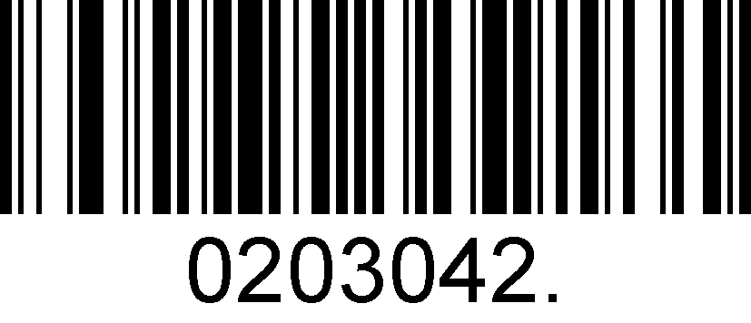
Validate And Transmit
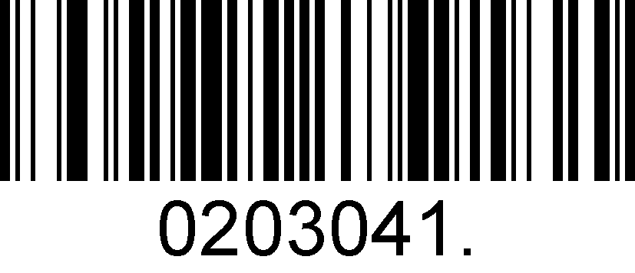
Validate No Transmit

Code 39 Append
This function allows the scanner to append several Code 39 barcode data together before transmitting to host. When the scanner encounters a Code 39 barcode with append character (ex. Space character), it buffers the data until it reads a Code 39 barcode which does not have append character. Then the data is transmitted in the order that the barcodes were read.

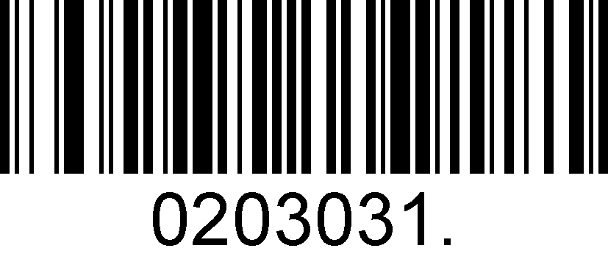
Enable Append
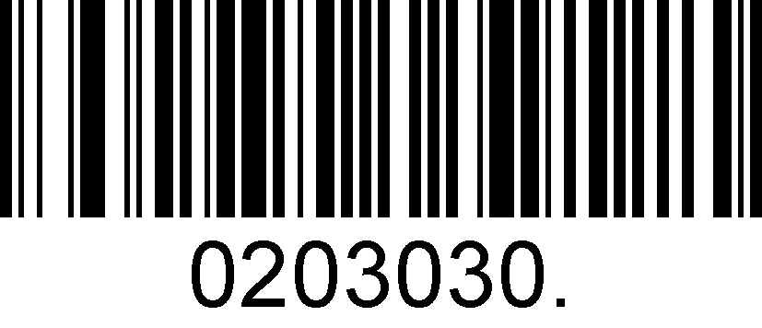
Disable Append

Code 39 Full ASCII
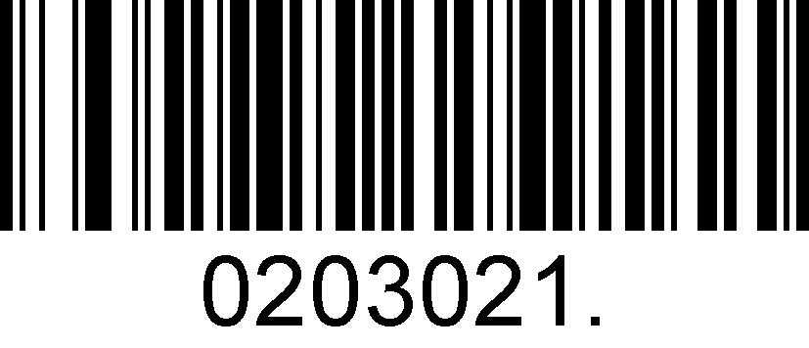
Enable Code 39 Full ASCII
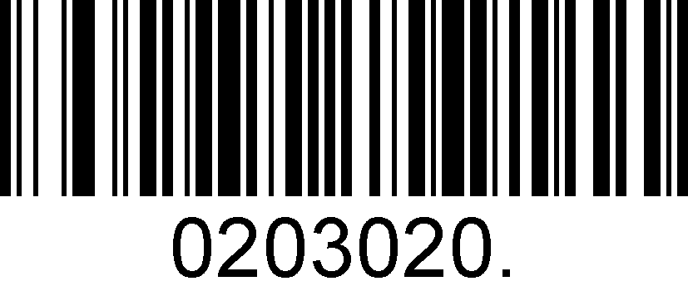
Disable Code 39 Full ASCII

Message Length for Code 39
Message length can be set to the maximum value or minimum value. The value between the maximum and the minimum is valid.
Code 39 max length command: 020308. The parameter of this command can be set from min to 48.
Code 39 min length command: 020307. The parameter of this command can be set from 1 to max.
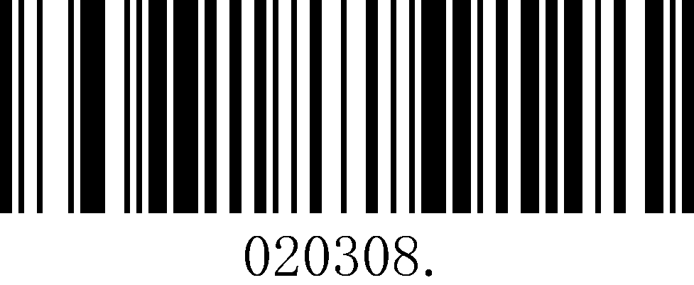
Set the Maximum Length
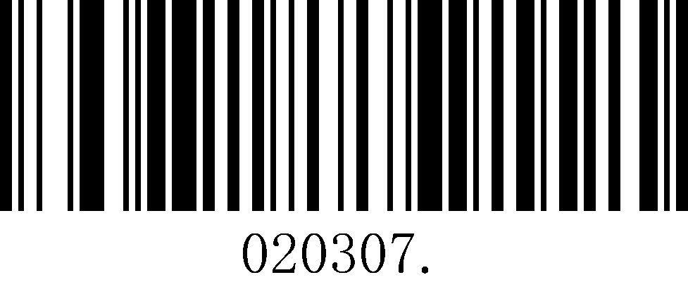
Set the Minimum Length

Example: Set the Barcode Message length of the minimum value is 10; the maximum value is 25:
1. Scan the Set the Maximum Length barcode.
2. Scan the numeric barcodes”2”and”5”in Appendix 3 .
3. Scan the Set the Minimum Length barcode.
4. Scan the numeric barcodes”1”and”0”in Appendix 3 .

Coda Bar
Enable/Disable Coda Bar
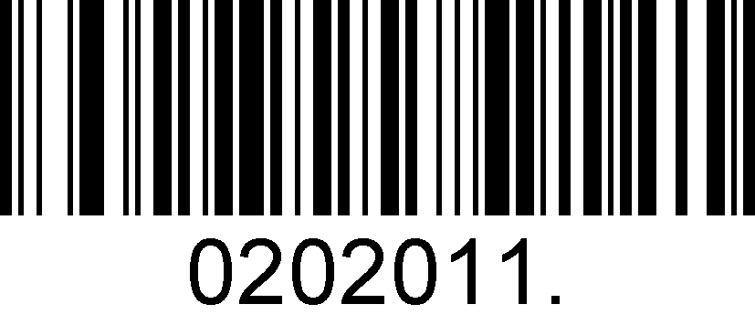
Enable Coda Bar

Disable Coda Bar

Message Length for Code Bar
Message length can be set to the maximum value or minimum value. The value between the maximum and the minimum is valid.
Code 39 max length command: 020206. The parameter of this command can be set from min to 60.
Code 39 min length command: 020205. The parameter of this command can be set from 2 to max.
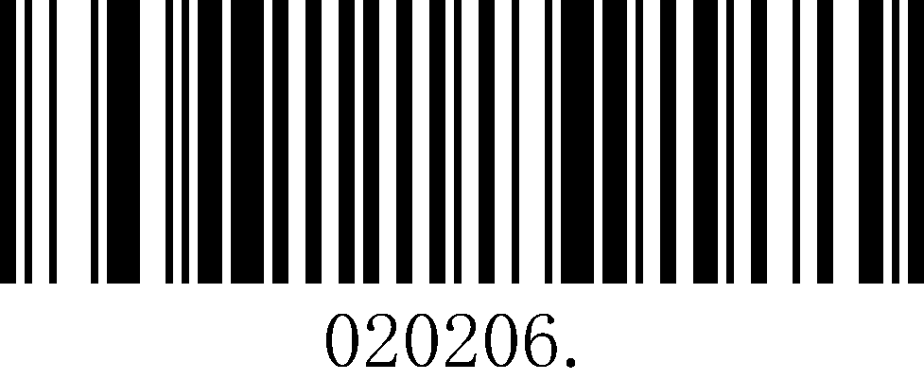
Set the Maximum Length
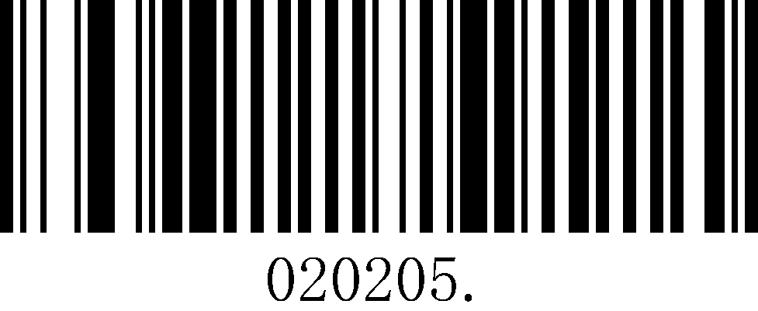
Set the Minimum Length

Example: Set the Barcode Message length of the minimum value is 10; the maximum value is 25:
1. Scan the Set the Maximum Length barcode.
2. Scan the numeric barcodes”2”and”5”in Appendix 3 .
3. Scan the Set the Minimum Length barcode.
4. Scan the numeric barcodes”1”and”0”in Appendix 3 .

Transmit Start/Stop Character
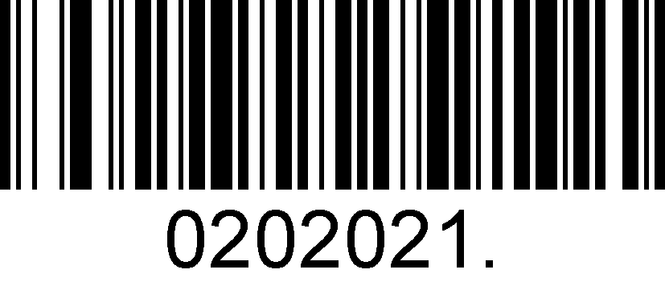
Transmit Start/Stop Character
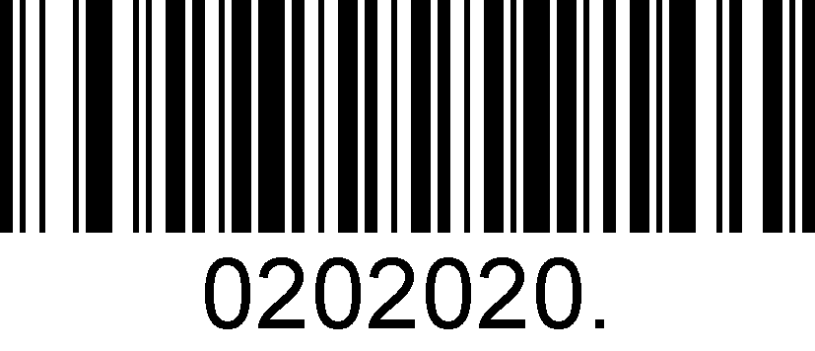
Do Not Transmit Start/Stop Character

Coda bar Check Character
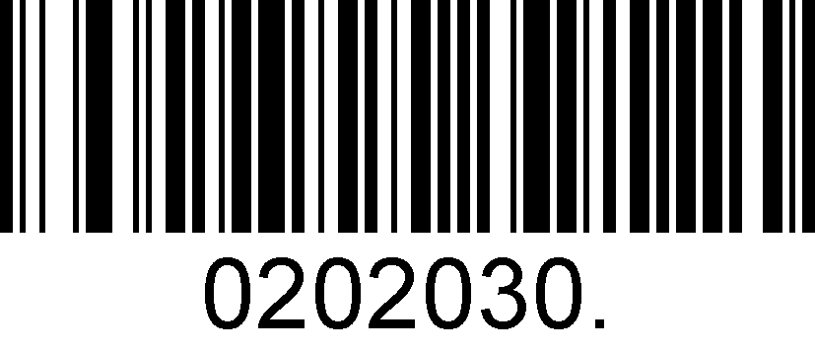
No Check Char
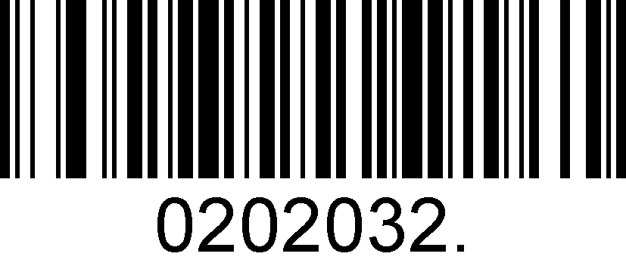
Validate And Transmit
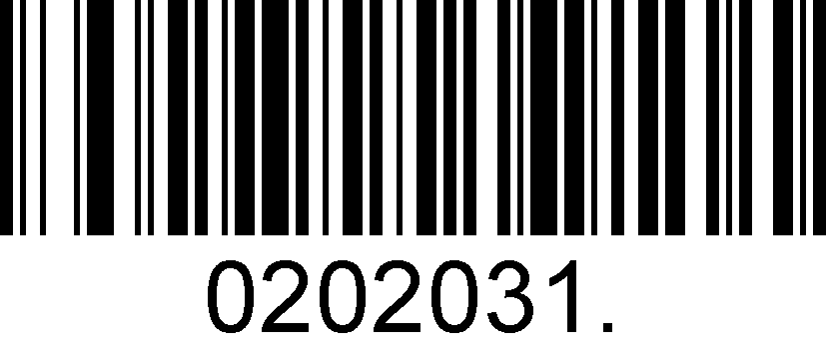
Validate No Transmit

Code 93
Enable/Disable Code 93
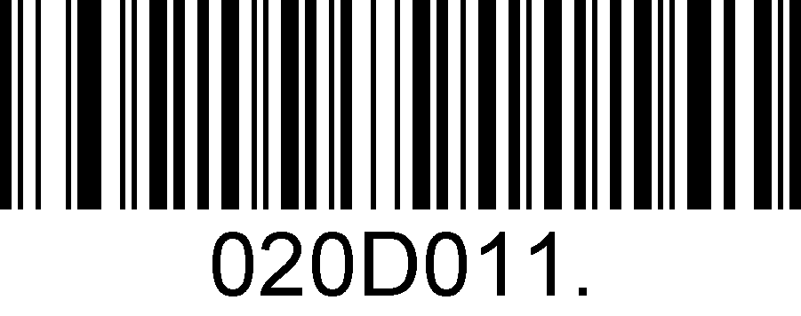
Enable Code 93

Disable Code 93

Message Length for Code 93
Message length can be set to the maximum value or minimum value. The value between the maximum and the minimum is valid.
Code 93 max length command: 020D03. The parameter of this command can be set from min to 80.
Code 93 min length command: 020D02. The parameter of this command can be set from 1 to max.

Set the Maximum Length

Set the Minimum Length

Example: Set the Barcode Message length of the minimum value is 10; the maximum value is 25:
1. Scan the Set the Maximum Length barcode.
2. Scan the numeric barcodes”2”and”5”in Appendix 3 .
3. Scan the Set the Minimum Length barcode.
4. Scan the numeric barcodes”1”and”0”in Appendix 3 .

Code 93 Append
This function allows the scanner to append several Code 93 barcode data together before transmitting to host. When the scanner encounters a Code 93 barcode with append character (ex. Space character), it buffers the data until it reads a Code 93 barcode which does not have append character. Then the data is transmitted in the order that the barcodes were read.

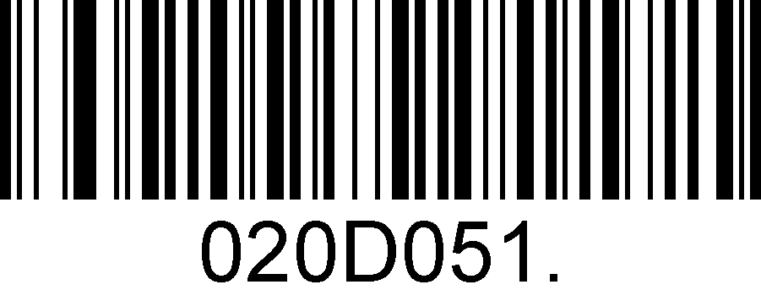
Enable Code 93 Append
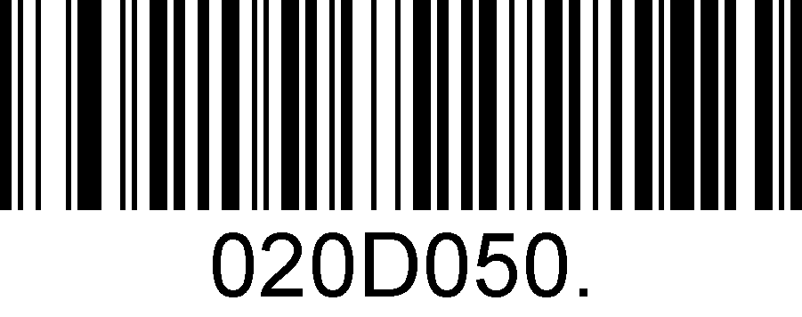
Disable Code 93 Append

GS1-128
Enable/Disable GS1-128
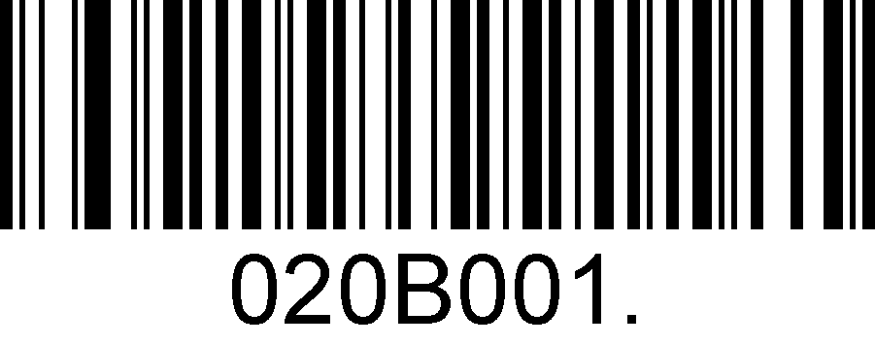
Enable GS1-128
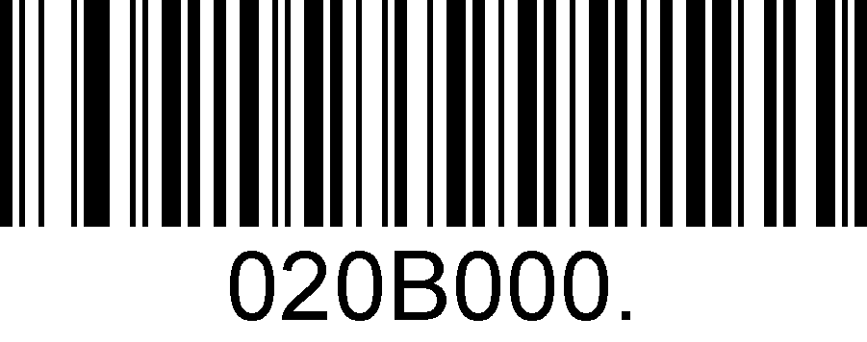
Disable GS1-128

Message Length for GS1-128
Message length can be set to the maximum value or minimum value. The value between the maximum and the minimum is valid.
GS1-128 max length command: 020B03. The parameter of this command can be set from min to 80.
GS1-128 min length command: 020B02. The parameter of this command can be set from 1 to max.

Set the Maximum Length

Set the Minimum Length

Example: Set the Barcode Message length of the minimum value is 10; the maximum value is 25:
1. Scan the Set the Maximum Length barcode.
2. Scan the numeric barcodes”2”and”5”in Appendix 3 .
3. Scan the Set the Minimum Length barcode.
4. Scan the numeric barcodes”1”and”0”in Appendix 3 .

MSI
Enable/Disable MSI
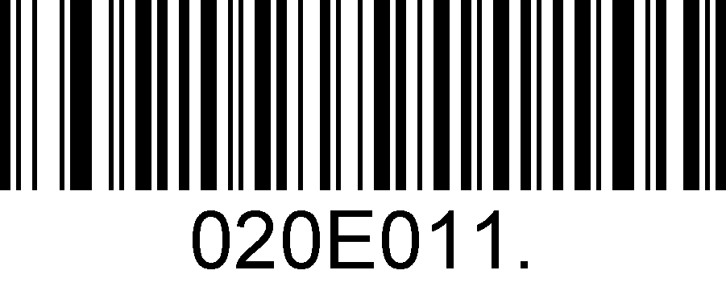
Enable MSI

Disable MSI

Message Length for MSI
Message length can be set to the maximum value or minimum value. The value between the maximum and the minimum is valid.
MSI max length command: 020E04. The parameter of this command can be set from min to 48.
MSI min length command: 020E03. The parameter of this command can be set from 4 to max.

Set the Maximum Length

Set the Minimum Length

Example: Set the Barcode Message length of the minimum value is 10; the maximum value is 25:
1. Scan the Set the Maximum Length barcode.
2. Scan the numeric barcodes”2”and”5”in Appendix 3 .
3. Scan the Set the Minimum Length barcode.
4. Scan the numeric barcodes”1”and”0”in Appendix 3 .

Code 11
Enable/Disable Code 11
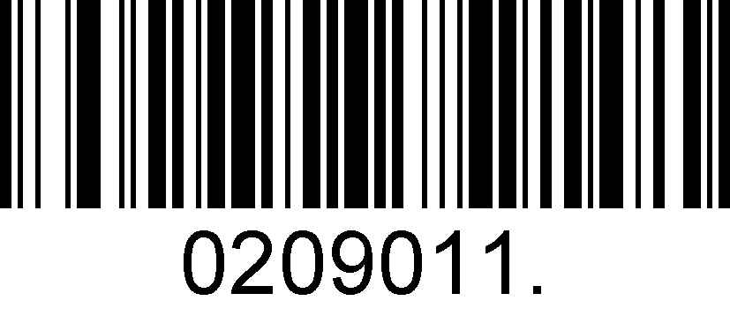
Enable Code 11

Disable Code 11

Code11 Check Digit(s)
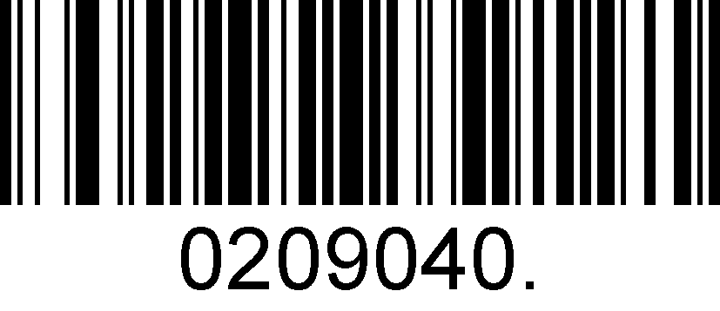
One Check Digit
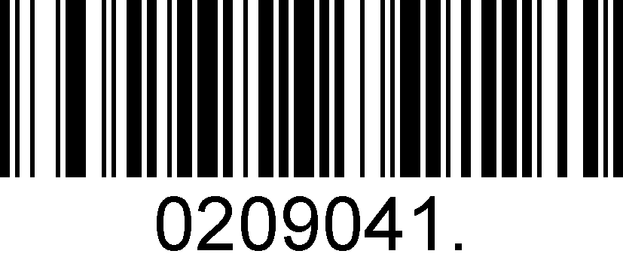
Two Check Digits

2D Symbologies

PDF 417
Enable/Disable PDF 417
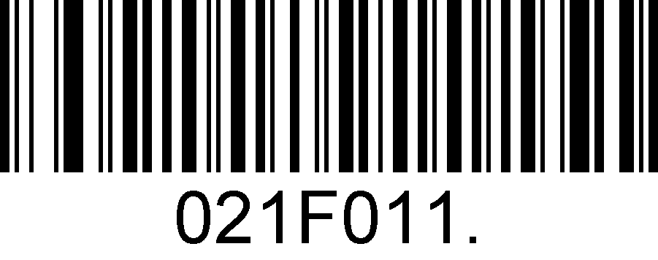
Enable PDF 417

Disable PDF 417

Enable/Disable Micro PDF 417
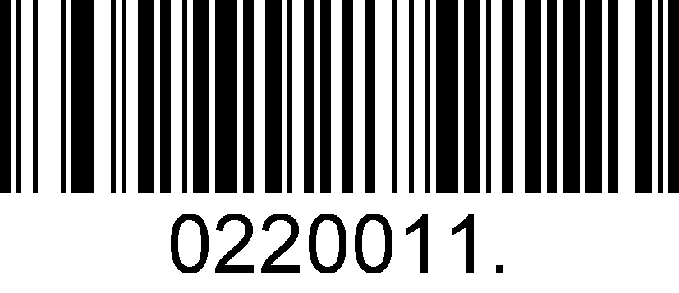
Enable Micro PDF 417
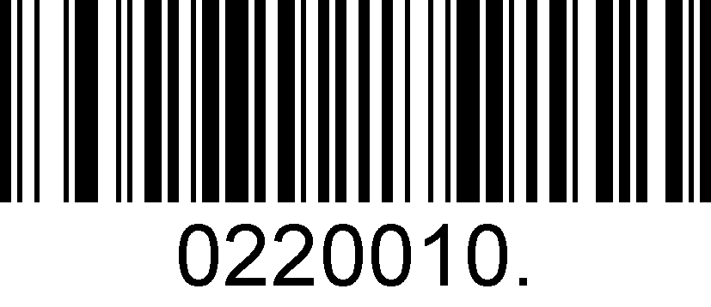
Disable Micro PDF 417

Message Length for PDF417
Message length can be set to the maximum value or minimum value. The value between the maximum and the minimum is valid.
PDF417 max length command: 021F06. The parameter of this command can be set from min to 2750.
PDF417 min length command: 021F05. The parameter of this command can be set from 1 to max.

Set the Maximum Length

Set the Minimum Length

Example: Set the Barcode Message length of the minimum value is 10; the maximum value is 25:
1. Scan the Set the Maximum Length barcode.
2. Scan the numeric barcodes”2”and”5”in Appendix 3 .
3. Scan the Set the Minimum Length barcode.
4. Scan the numeric barcodes”1”and”0”in Appendix 3 .

QR Code
Enable/Disable QR Code
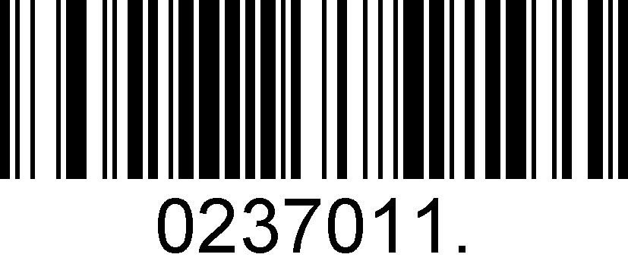
Enable QR Code
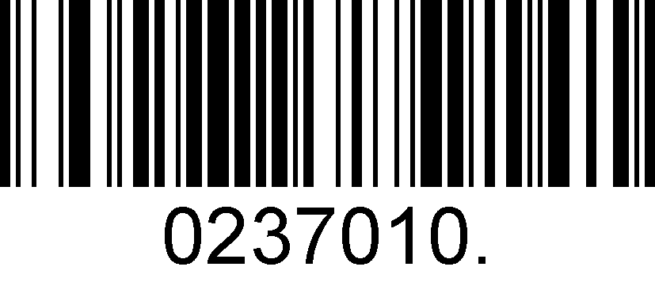
Disable QR Code

Message Length for QR
Message length can be set to the maximum value or minimum value. The value between the maximum and the minimum is valid.
QR max length command: 023703. The parameter of this command can be set from min to 7089.
QR min length command: 023702. The parameter of this command can be set from 1 to max.
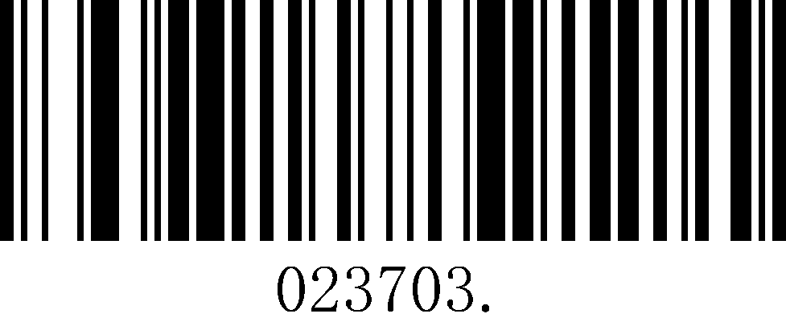
Set the Maximum Length
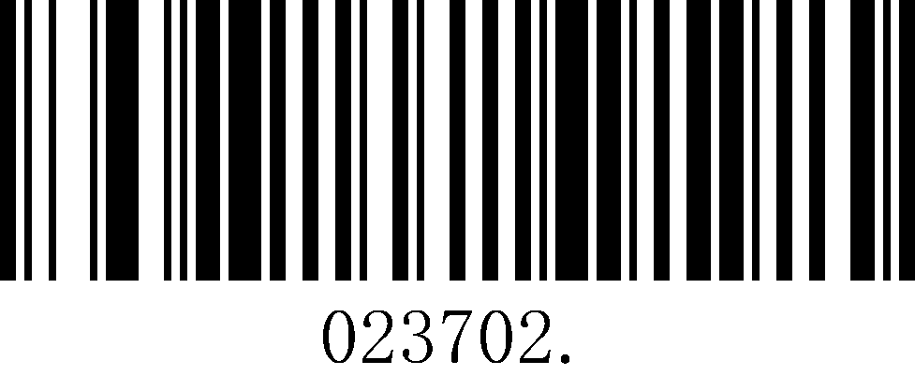
Set the Minimum Length

Example: Set the Barcode Message length of the minimum value is 10; the maximum value is 25:
1. Scan the Set the Maximum Length barcode.
2. Scan the numeric barcodes”2”and”5”in Appendix 3 .
3. Scan the Set the Minimum Length barcode.
4. Scan the numeric barcodes”1”and”0”in Appendix 3 .

QR Code Append
This function allows the scanner to append several QR barcode data together before transmitting to host. When the scanner encounters a QR barcode with append character (ex. Space character), it buffers the data until it reads a QR barcode which does not have append character. Then the data is transmitted in the order that the barcodes were read.

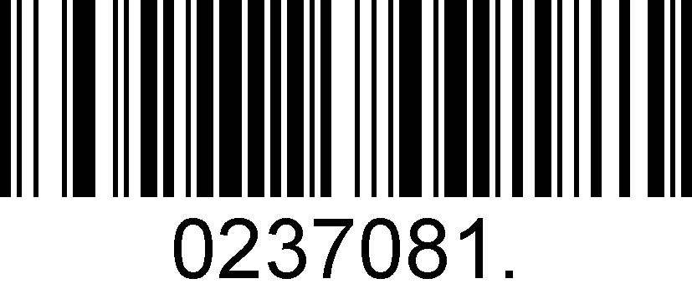
Enable QR Code Append
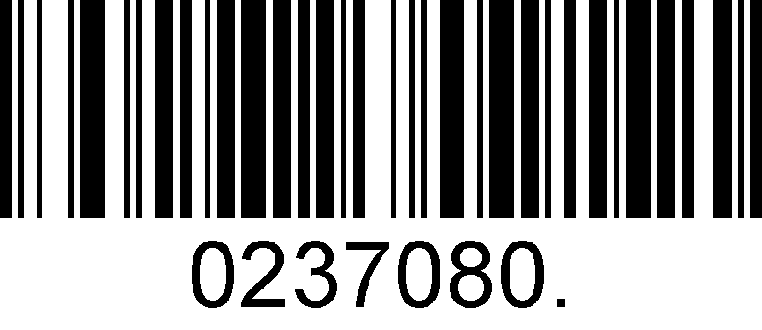
Disable QR Code Append

Data Matrix
Enable/Disable Data Matrix
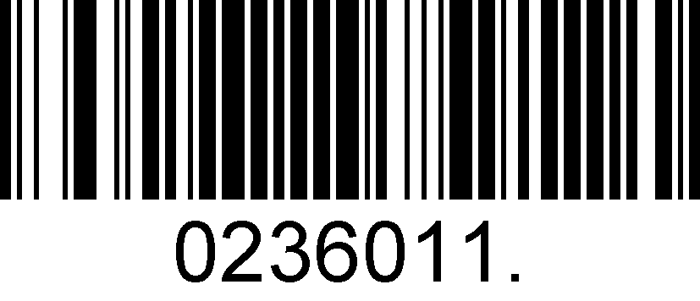
Enable Data Matrix
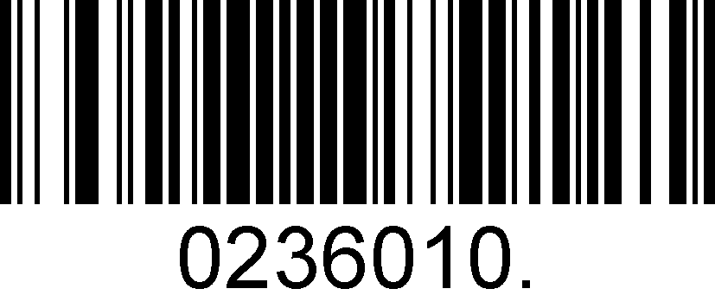
Disable Data Matrix

Message Length for Data Matrix
Message length can be set to the maximum value or minimum value. The value between the maximum and the minimum is valid.
Data Matrix max length command: 023603. The parameter of this command can be set from min to 3116.
Data Matrix min length command: 023602. The parameter of this command can be set from 1 to max.
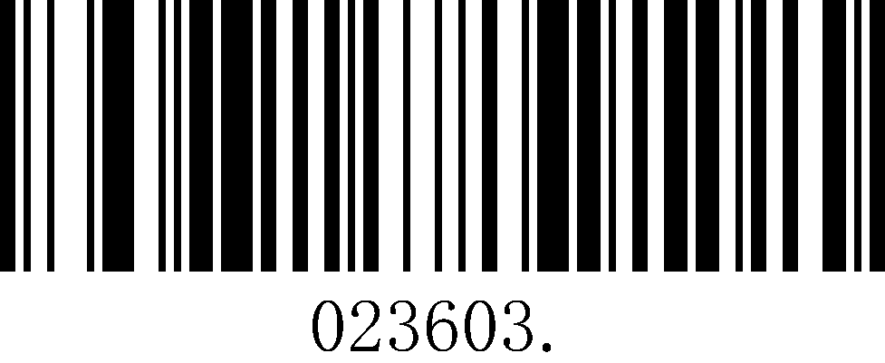
Set the Maximum Length
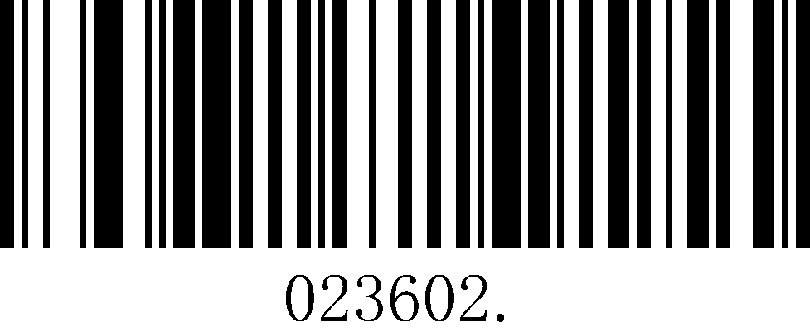
Set the Minimum Length

Example: Set the Barcode Message length of the minimum value is 10; the maximum value is 25:
1. Scan the Set the Maximum Length barcode.
2. Scan the numeric barcodes”2”and”5”in Appendix 3 .
3. Scan the Set the Minimum Length barcode.
4. Scan the numeric barcodes”1”and”0”in Appendix 3 .

Maxi code
Enable/Disable Maxi code
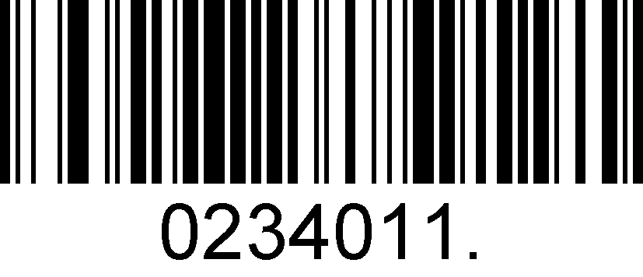
Enable Maxi Code
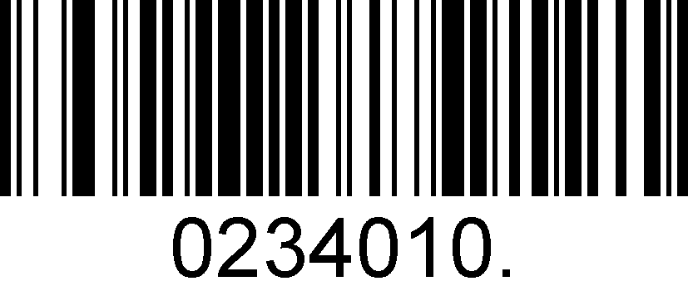
Disable Maxi Code

Message Length for Maxi Code
Message length can be set to the maximum value or minimum value. The value between the maximum and the minimum is valid.
Maxi Code max length command: 023403. The parameter of this command can be set from min to 150.
Maxi Code min length command: 023402. The parameter of this command can be set from 1 to max.
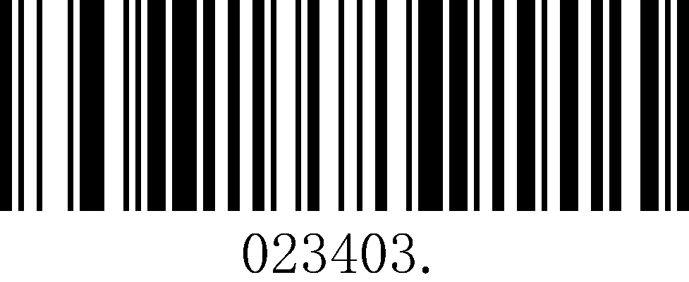
Set the Maximum Length
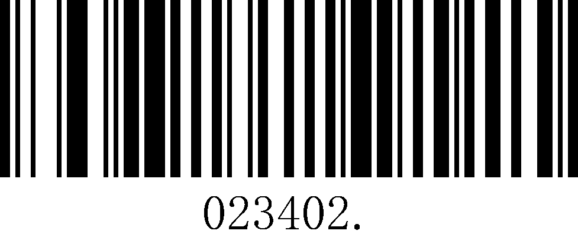
Set the Minimum Length

Example: Set the Barcode Message length of the minimum value is 10; the maximum value is 25:
1. Scan the Set the Maximum Length barcode.
2. Scan the numeric barcodes”2”and”5”in Appendix 3 .
3. Scan the Set the Minimum Length barcode.
4. Scan the numeric barcodes”1”and”0”in Appendix 3 .

Aztec
Enable/Disable Aztec
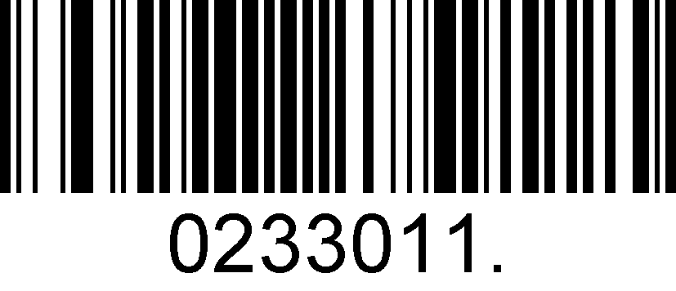
Enable Aztec
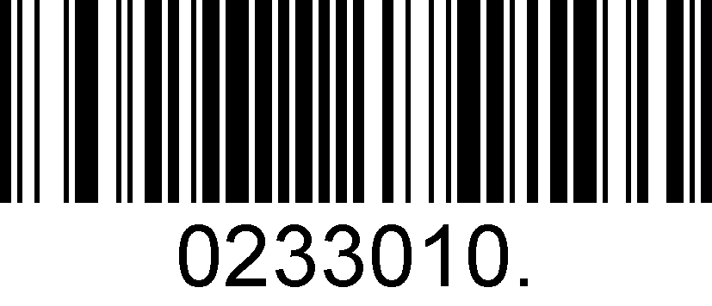
Disable Aztec

Message Length for Aztec
Message length can be set to the maximum value or minimum value. The value between the maximum and the minimum is valid.
Maxi Code max length command: 023306. The parameter of this command can be set from min to 3282.
Maxi Code min length command: 023305. The parameter of this command can be set from 1 to max.
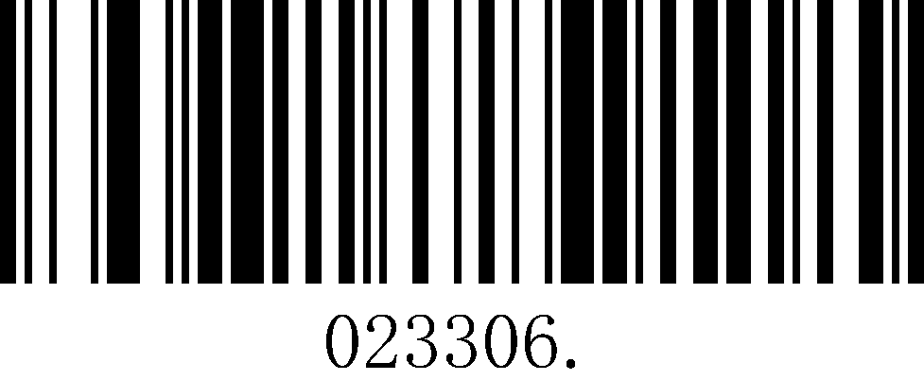
Set the Maximum Length
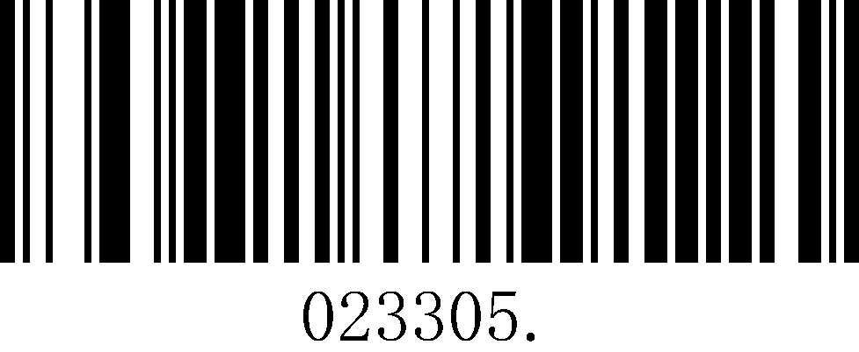
Set the Minimum Length

Example: Set the Barcode Message length of the minimum value is 10; the maximum value is 25:
1. Scan the Set the Maximum Length barcode.
2. Scan the numeric barcodes”2”and”5”in Appendix 3 .
3. Scan the Set the Minimum Length barcode.
4. Scan the numeric barcodes”1”and”0”in Appendix 3 .

Aztec Append
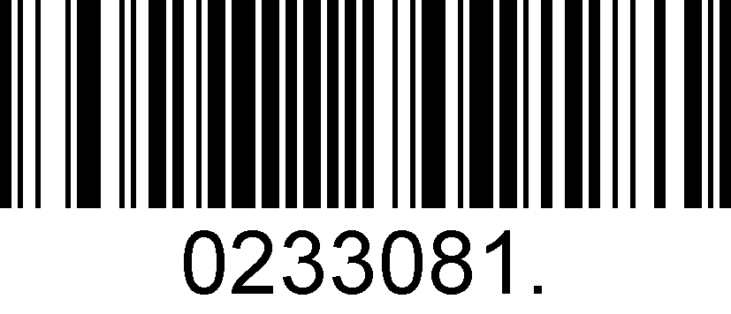
Enable Aztec Append
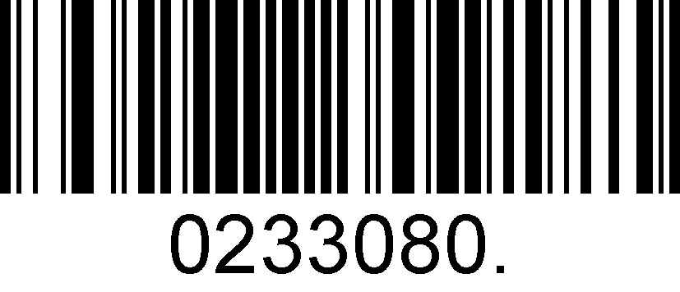
Disable Aztec Append

Hanxin
Enable/Disable Hanxin
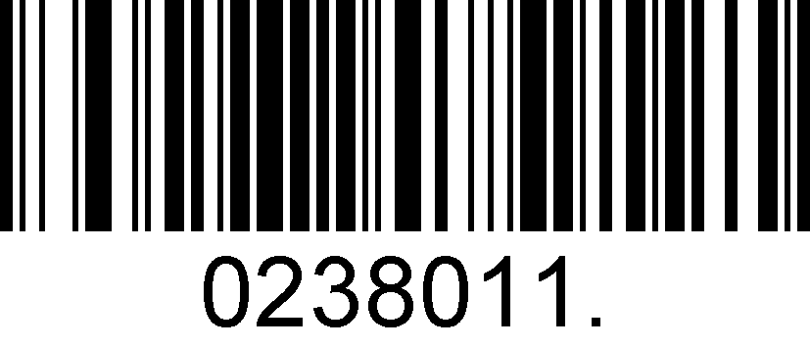
Enable Hanxin
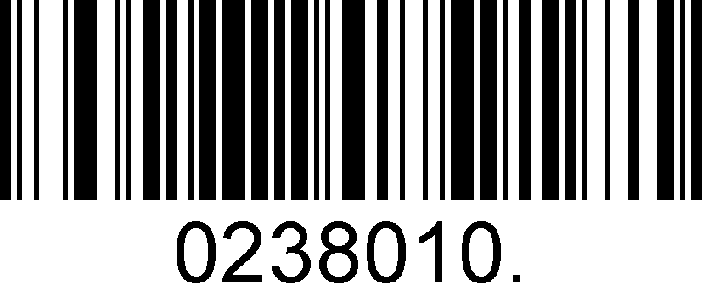
Disable Hanxin
Message Length for Hanxin
Message length can be set to the maximum value or minimum value. The value between the maximum and the minimum is valid.
Hanxin max length command: 023803. The parameter of this command can be set from min to 7833.
Hanxin min length command: 023802. The parameter of this command can be set from 1 to max.
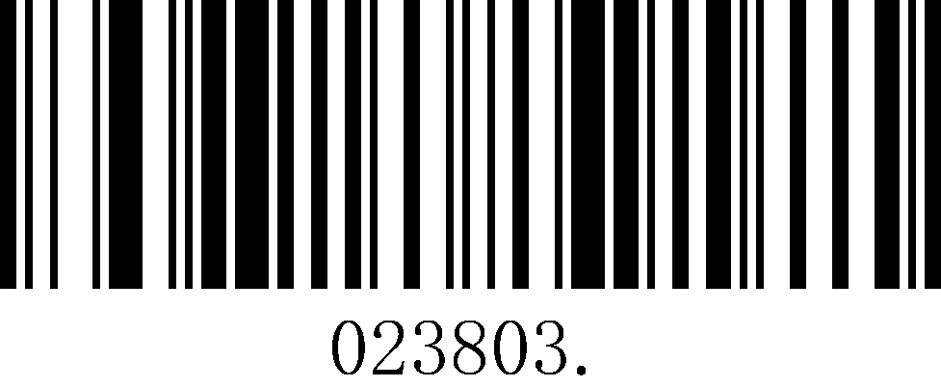
Set the Maximum Length
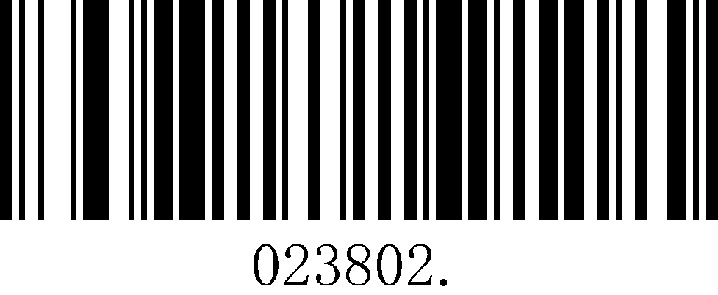
Set the Minimum Length

Example: Set the Barcode Message length of the minimum value is 10; the maximum value is 25:
1. Scan the Set the Maximum Length barcode.
2. Scan the numeric barcodes”2”and”5”in Appendix 3 .
3. Scan the Set the Minimum Length barcode.
4. Scan the numeric barcodes”1”and”0”in Appendix 3 .

Postal Symbologies

China Postal Code
Enable/Disable China Postal Code
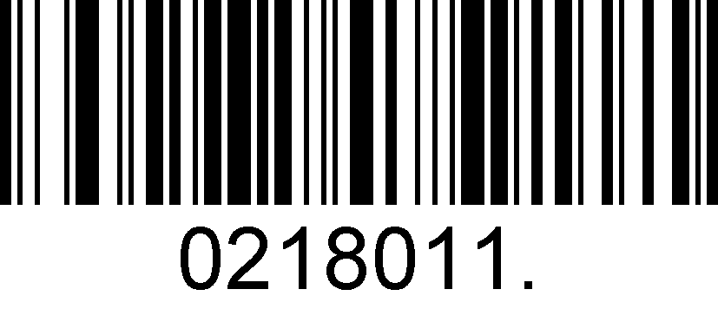
Enable China Postal Code
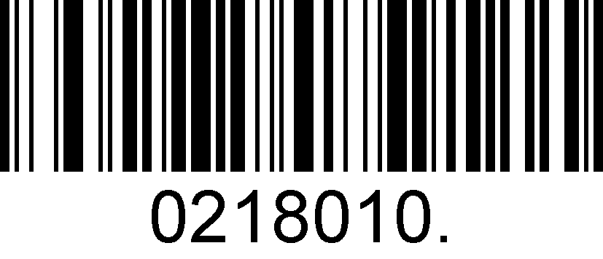
Disable China Postal Code

Telepen
Enable/Disable Telepen
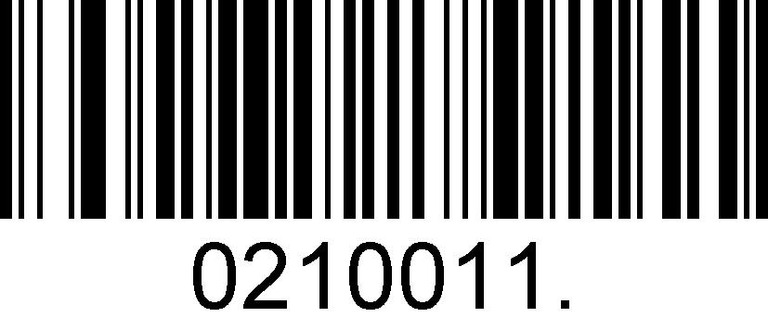
Enable China Telepen
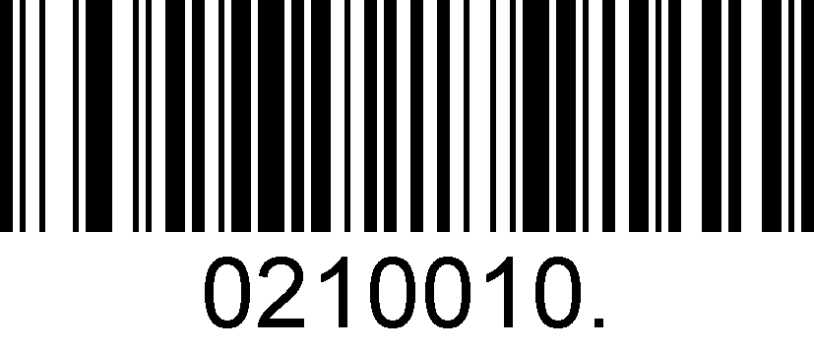
Disable China Telepen

Appendix

Appendix 1: AIM ID Table
Symbology | AIM ID | Remark | SuperLead  (Hex)
All Symbologies |  |  | 99
EAN-13 | ]E0 | Standard EAN-13 | 64
EAN-13 | ]E3 | EAN-13 + 2/5-Digit Add-On Code | 64
EAN-8 | ]E4 | Standard EAN-8 | 44
EAN-8 | ]E4…]E1… | EAN-8 + 2-Digit Add-On Code | 44
EAN-8 | ]E4…]E2… | EAN-8 + 5-Digit Add-On Code | 44
UPC-E | ]E0 | Standard UPC-E | 45
UPC-E | ]E3 | UPC-E + 2/5-Digit Add-On Code | 45
UPC-A | ]E0 | Standard UPC-A | 63
UPC-A | ]E3 | UPC-A + 2/5-Digit Add-On Code | 63
Code 128 | ]C0 | Standard Code 128 | 6A
GS1-128 | ]C1 | FNC1 is the character right after the start character | 49
Interleaved 2 of 5 | ]I0 | No parity check | 65
Interleaved 2 of 5 | ]I1 | Transmit check digit after parity check | 65
Interleaved 2 of 5 | ]I3 | Do not transmit check digit after parity check | 65
Industrial 2 of 5 | ]S0 | Not specified | 66
Standard 2 of 5 | ]R0 | No parity check | 66
Standard 2 of 5 | ]R8 | One check digit, MOD10; do not transmit check digit | 66
Standard 2 of 5 | ]R9 | One check digit, MOD10; transmit check digit | 66
Code 39 | ]A0 | Transmit barcodes as is; Full ASCII disabled; no parity check | 62
Code 39 | ]A1 | One check digit, MOD43; transmit check digit | 62
Code 39 | ]A3 | One check digit, MOD43; do not transmit check digit | 62
Code 39 | ]A4 | Full ASCII enabled; no parity check | 62
Code 39 | ]A5 | Full ASCII enabled; transmit check digit | 62
Code 39 | ]A7 | Full ASCII enabled; do not transmit check digit | 62
Codebar | ]F0 | Standard Codebar | 61
Codebar | ]F2 | Transmit check digit after parity check | 61
Codebar | ]F4 | Do not transmit check digit after parity check | 61
Code 93 | ]G0 | Standard Code 93 | 69
Code 11 | ]H0 | One check digit MOD11; transmit check digit | 68
Code 11 | ]H1 | Two check digits, MOD11/MOD11; transmit check digit | 68
Code 11 | ]H3 | Do not transmit check digit after parity check | 68
Code 11 | ]H9 | No parity check | 68
GS1-DataBar (RSS) | ]e0 | Standard GS1-DataBar | 79
Matrix 2 of 5 | ]X0 | Specified by the manufacturer | 6D
Matrix 2 of 5 | ]X1 | No parity check | 6D
Matrix 2 of 5 | ]X2 | One check digit, MOD10; transmit check digit | 6D
Matrix 2 of 5 | ]X3 | One check digit, MOD11; do not transmit check digit | 6D
PDF417 | ]L0 | Comply with 1994 PDF417 specifications | 72
Data Matrix | ]d0 | ECC000 - ECC140 | 77
Data Matrix | ]d1 | ECC200 | 77
Data Matrix | ]d2 | ECC200, FNC1 is the 1st or 5th character after the start character | 77
Data Matrix | ]d3 | ECC200, FNC1 is the 2nd or 6th character after the start character | 77
Data Matrix | ]d4 | ECC200, ECI included | 77
Data Matrix | ]d5 | ECC200, FNC1 is the 1st or 5th character after the start character,ECI included | 77
Data Matrix | ]d6 | ECC200, FNC1 is the 2nd or 6th character after the start character,ECI included | 77
QR Code | ]Q0 | QR1 | 73
QR Code | ]Q1 | 2005 version, ECI excluded | 73
QR Code | ]Q2 | 2005 version, ECI included | 73
QR Code | ]Q3 | QR Code 2005, ECI excluded, FNC1 is the 1st character after the start character | 73
QR Code | ]Q4 | QR Code 2005, ECI included, FNC1 is the 1st character after the start character | 73
QR Code | ]Q5 | QR Code 2005,ECI excluded,FNC1 is the 2nd character after the start character | 73
QR Code | ]Q6 | QR Code 2005, ECI included, FNC1 is the 2nd character after the start character | 73

Reference: ISO/IEC 15424:2008 Information technology – Automatic identification and data capture techniques – Data Carrier
Identifiers (including Symbology Identifiers).

Appendix 2: ASCII Table

Hex | Dec | Char | Predefined keystrokes | CTRL+X functions
00 | 0 | NUL (Null char.) | Reserved | CTRL+@
01 | 1 | SOH (Start of Header) | Enter | CTRL+A
02 | 2 | STX (Start of Text) | Caps Lock | CTRL+B
03 | 3 | ETX (End of Text) | ALT Make | CTRL+C
04 | 4 | EOT (End of Transmission) | ALT Break | CTRL+D
05 | 5 | ENQ (Enquiry) | CTRL Make | CTRL+E
06 | 6 | ACK (Acknowledgment) | CTRL Break | CTRL+F
07 | 7 | BEL (Bell) | Enter | CTRL+G
08 | 8 | BS (Backspace) | N/A | CTRL+H
09 | 9 | HT (Horizontal Tab) | Tab | CTRL+I
0A | 10 | LF (Line Feed) | N/A | CTRL+J
0B | 11 | VT (Vertical Tab) | Tab | CTRL+K
0C | 12 | FF (Form Feed) | Delete | CTRL+L
0D | 13 | CR (Carriage Return) | Enter | CTRL+M
0E | 14 | SO (Shift Out) | Insert | CTRL+N
0F | 15 | SI (Shift In) | ESC | CTRL+O
10 | 16 | DLE (Data Link Escape) | F11 | CTRL+P
11 | 17 | DC1 (XON) (Device Control 1) | Home | CTRL+Q
12 | 18 | DC2 (Device Control 2) | PrtScn | CTRL+R
13 | 19 | DC3 (XOFF) (Device Control 3) | Backspace | CTRL+S
14 | 20 | DC4 (Device Control 4) | Back Tab | CTRL+T
15 | 21 | NAK (Negative Acknowledgment) | F12 | CTRL+U
16 | 22 | SYN (Synchronous Idle) | F1 | CTRL+V
17 | 23 | ETB (End of Trans. Block) | F2 | CTRL+W
18 | 24 | CAN (Cancel) | F3 | CTRL+X
19 | 25 | EM (End of Medium) | F4 | CTRL+Y
1A | 26 | SUB (Substitute) | F5 | CTRL+Z
1B | 27 | ESC (Escape) | F6 | CTRL+[
1C | 28 | FS (File Separator) | F7 | CTRL+\
1D | 29 | GS (Group Separator) | F8 | CTRL+]
1E | 30 | RS (Request to Send) | F9 | CTRL+^
1F | 31 | US (Unit Separator) | F10 | CTRL+-

Hex | Dec | Char
20 | 32 | SP (Space)
21 | 33 | ! (Exclamation Mark)
22 | 34 | " (Double Quote)
23 | 35 | # (Number Sign)
24 | 36 | $ (Dollar Sign)
25 | 37 | % (Percent)
26 | 38 | & (Ampersand)
27 | 39 | ` (Single Quote)
28 | 40 | ( (Right / Closing Parenthesis)
29 | 41 | ) (Right / Closing Parenthesis)
2A | 42 | * (Asterisk)
2B | 43 | + (Plus)
2C | 44 | , (Comma)
2D | 45 | - (Minus / Dash)
2E | 46 | . (Dot)
2F | 47 | / (Forward Slash)
30 | 48 | 0
31 | 49 | 1
32 | 50 | 2
33 | 51 | 3
34 | 52 | 4
35 | 53 | 5
36 | 54 | 6
37 | 55 | 7
38 | 56 | 8
39 | 57 | 9
3A | 58 | : (Colon)
3B | 59 | ; (Semi-colon)
3C | 60 | < (Less Than)
3D | 61 | = (Equal Sign)
3E | 62 | > (Greater Than)
3F | 63 | ? (Question Mark)
40 | 64 | @ (AT Symbol)
41 | 65 | A
42 | 66 | B
43 | 67 | C
Hex | Dec | Char
44 | 68 | D
45 | 69 | E
46 | 70 | F
47 | 71 | G
48 | 72 | H
49 | 73 | I
4A | 74 | J
4B | 75 | K
4C | 76 | L
4D | 77 | M
4E | 78 | N
4F | 79 | O
50 | 80 | P
51 | 81 | Q
52 | 82 | R
53 | 83 | S
54 | 84 | T
55 | 85 | U
56 | 86 | V
57 | 87 | W
58 | 88 | X
59 | 89 | Y
5A | 90 | Z
5B | 91 | [ (Left / Opening Bracket)
5C | 92 | \ (Back Slash)
5D | 93 | ] (Right / Closing Bracket)
5E | 94 | ^ (Caret / Circumﬂex)
5F | 95 | _ (Underscore)
60 | 96 | ' (Grave Accent)
61 | 97 | a
62 | 98 | b
63 | 99 | c
64 | 100 | d
65 | 101 | e
66 | 102 | f
67 | 103 | g
Hex | Dec | Char
68 | 104 | h
69 | 105 | i
6A | 106 | j
6B | 107 | k
6C | 108 | l
6D | 109 | m
6E | 110 | n
6F | 111 | o
70 | 112 | p
71 | 113 | q
72 | 114 | r
73 | 115 | s
74 | 116 | t
75 | 117 | u
76 | 118 | v
77 | 119 | w
78 | 120 | x
79 | 121 | y
7A | 122 | z
7B | 123 | { (Left/ Opening Brace)
7C | 124 | | (Vertical Bar)
7D | 125 | } (Right/Closing Brace)
7E | 126 | ~ (Tilde)
7F | 127 | DEL (Delete)

Appendix 3: Digit Barcodes
0 | 1 | 2 | 3
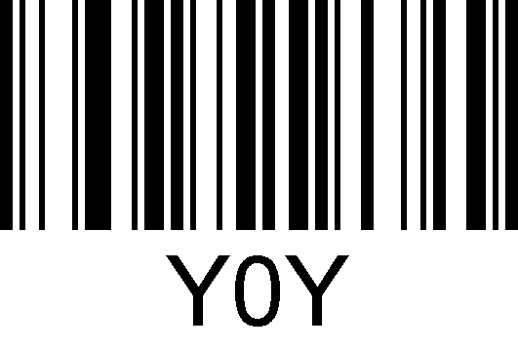 | 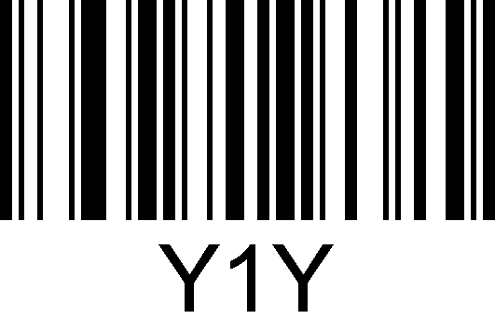 | 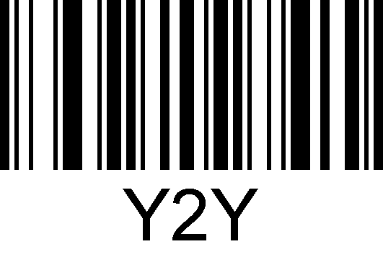 | 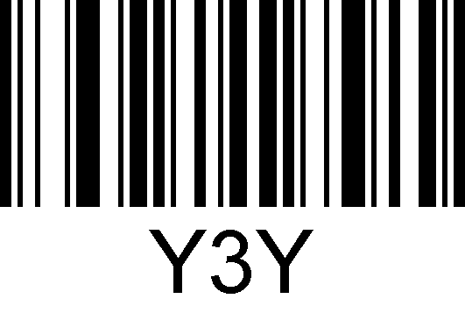
4 | 5 | 6 | 7
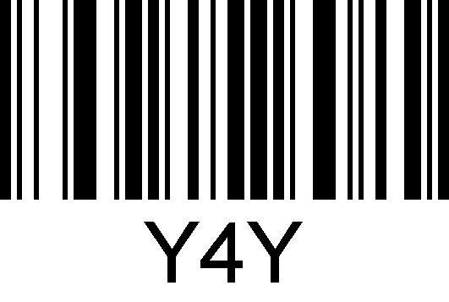 | 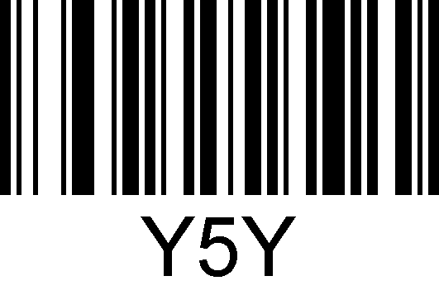 | 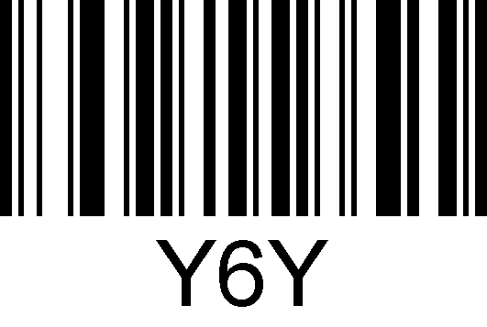 | 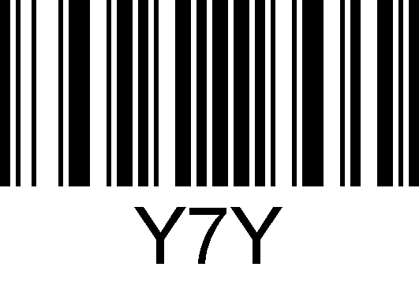
8 | 9 | A | B
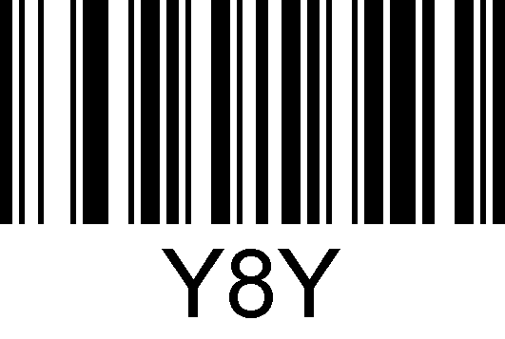 | 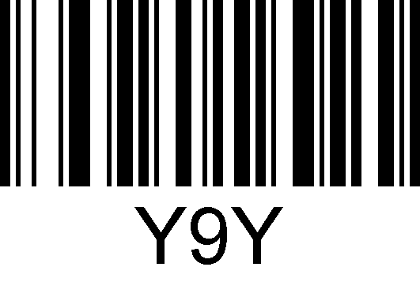 |  | 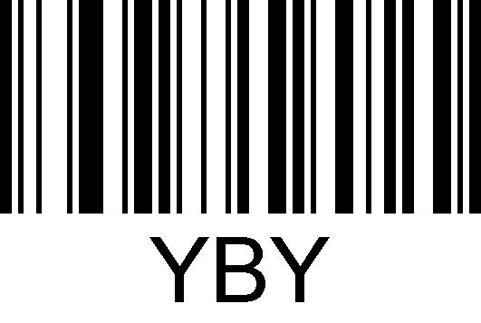
C | D | E | F
 | 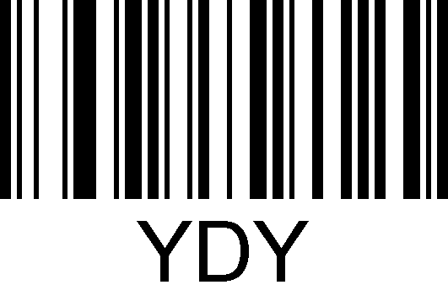 |  | 

